City of Gardner

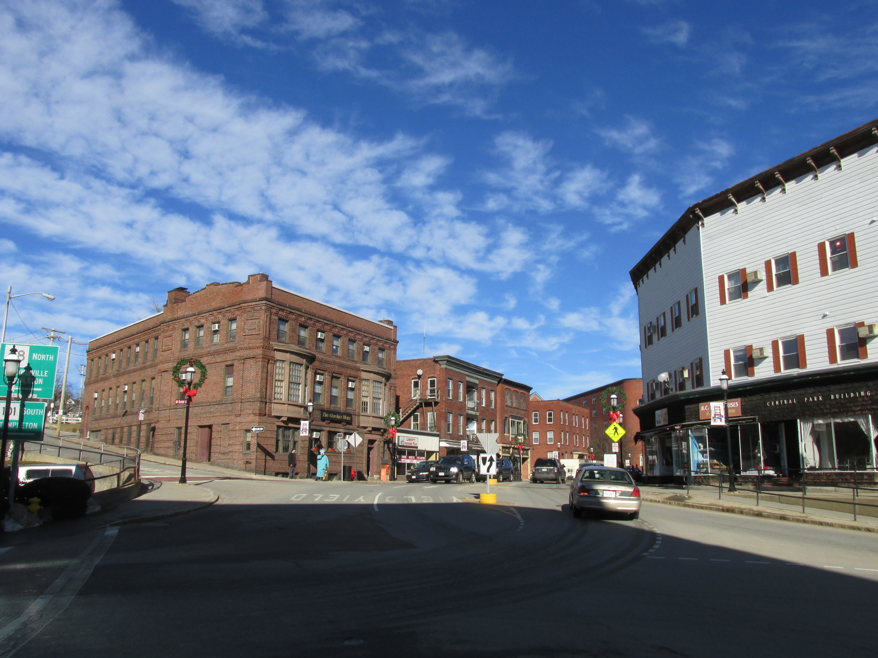

Community Resilience Building Workshop

Summary of Findings

September 30, 2020

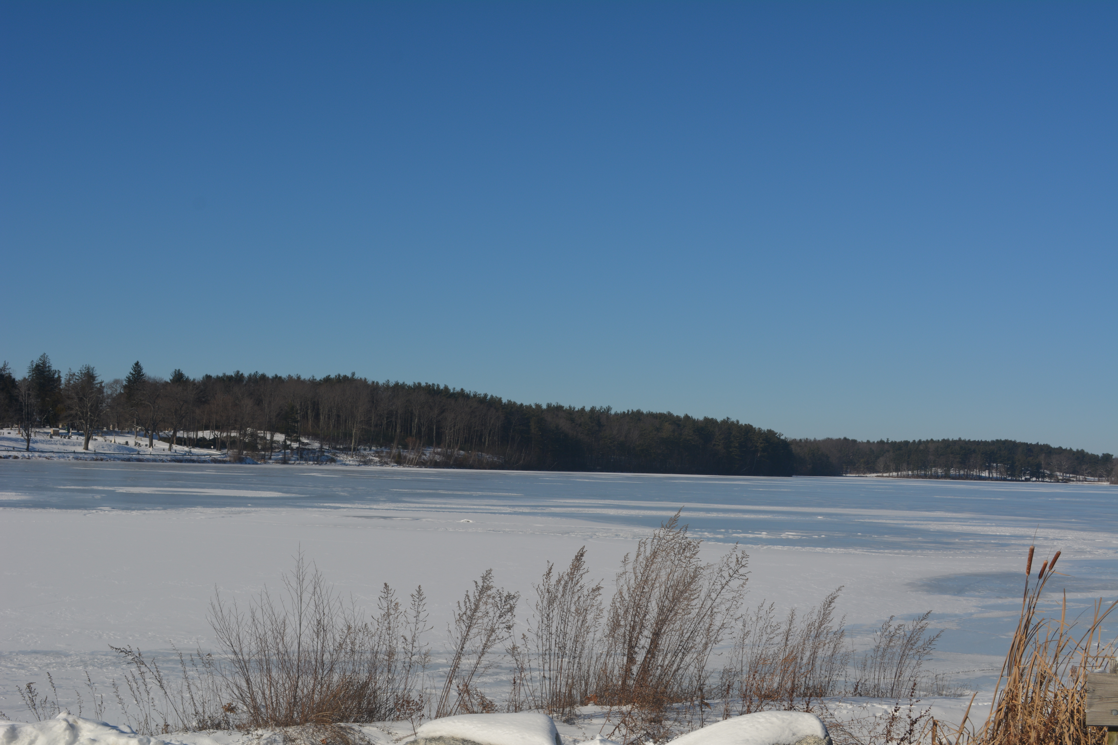Crystal Lake (Source: Dodson & Flinker)

Cover Photo
Downtown Gardner (Source: Wikimedia)

Table of Contents
1. Overview 1
2. Community Resilience Building Workshop 2
3. Top Hazards & Vulnerable Areas 6
Areas of Concern (Specific Locations) 7
4. Current Concerns and Challenges Presented By Hazards and Climate Change 9
Projected Changes in Gardner’s Climate 9
Impacts of Climate Change on Hazards in Gardner 11
5. Specific Categories of Concerns and Challenges 15
Infrastructural Vulnerabilities 15
Societal Vulnerabilities 24
Environmental Vulnerabilities 29
6. Current Strengths and Assets 36
Infrastructural Strengths 36
Societal Strengths 36
Environmental Strengths 37
7. Top Recommendations to Improve Resilience to Hazards 38
Additional Priorities 40
8. Possible Funding Sources 43
9. CRB Workshop Invitees and Participants 44
10. Acknowledgements 48
11. MVP Project Team 48
12. Citation 48
13. References 49
14. Appendices 51
1. Combined Workshop Matrix 51

1. Overview
As the effects of climate change become more apparent globally and locally, the City of Gardner, like communities across the Commonwealth of Massachusetts, has begun to plan for the unavoidable impacts of climate change. In recent decades, the impacts of climate change have become widely evident. Average annual temperatures in Massachusetts have increased by about 3°F over the past century with greater increases in more recent decades—half of a degree per decade since the 1970s. Meanwhile Massachusetts has seen an 81% increase in extreme precipitation events since 1948.
Mindful that its future will be shaped by climate change, Gardner applied for and was awarded a grant for Municipal Vulnerability Preparedness (MVP) Planning from the Executive Office of Energy and Environmental Affairs (EOEEA) MVP program. The MVP program is Massachusetts’ flagship effort to support towns and cities in building local resilience and preparing for climate change. Municipalities that complete the MVP Planning process become “MVP-certified” which makes them eligible for MVP Action grants to implement projects identified during the planning process. Communities across the state have received millions of dollars in recent years to protect or update local infrastructure, harness natural processes to reduce flooding and its impacts, update local bylaws, improve emergency communication, and more. Gardner received funding to complete a Municipal Vulnerability Preparedness Plan with an expanded scope for an associated Climate Resilience Tree Planting Plan.
This report describes Gardner’s MVP planning process, records the key information that it gathered, and presents recommendations for increasing resilience in Gardner.
This plan is focused on climate change adaptation—moderating the harm caused by climate change). It does not address climate change mitigation—the long-term reduction of climate change by reducing greenhouse gas emissions and sequestering atmospheric carbon. Both climate change mitigation and adaptation will be required to secure a livable future for Gardner.

2. Community Resilience Building Workshop
Gardner received a Municipal Vulnerability Preparedness (MVP) grant in 2019. The project was led by Lyndsy Butler and Jeff Legros, supported by a core team which included Rachael Catlow (Department of Public Works), Dane Arnold (DPW), Robert Oliva (DPW), Chris Coughlin (City Engineer), Anna Wilkins (North County Land Trust), David Beauregard (Conservation Commission), Paul Topolski (Emergency Management), Ivan Ussach (Millers River Watershed Council), and Trevor Beauregard (Department of Community Development & Planning). Andrew Smith, Massachusetts EEA’s regional MVP coordinator for this project, provided additional support.
The Core Team selected MVP-certified provider Dodson & Flinker of Florence, Massachusetts to facilitate the process. The planning process began with a kick-off meeting on December 19, 2019, which introduced the MVP planning processes. Core group members discussed Gardner’s key natural hazards, and its strengths and vulnerabilities. They identified critical facilities in the community, discussed local priorities for the MVP planning process, and reviewed a draft map of Gardner for the workshop.
Over the course of the following months, the project leads also coordinated with Dodson & Flinker on an urban forestry plan for Gardner’s downtown and environmental justice areas, also funded by the MVP Program. Dodson & Flinker conducted an inventory of Gardner’s public street trees in the target area including the locations, species, size, and conditions of trees that shade the public right-of-way within downtown. The project team then identified actions to improve Gardner’s urban forest, including tools for engaging residents and business owners. This process was integrated into the MVP Planning Process

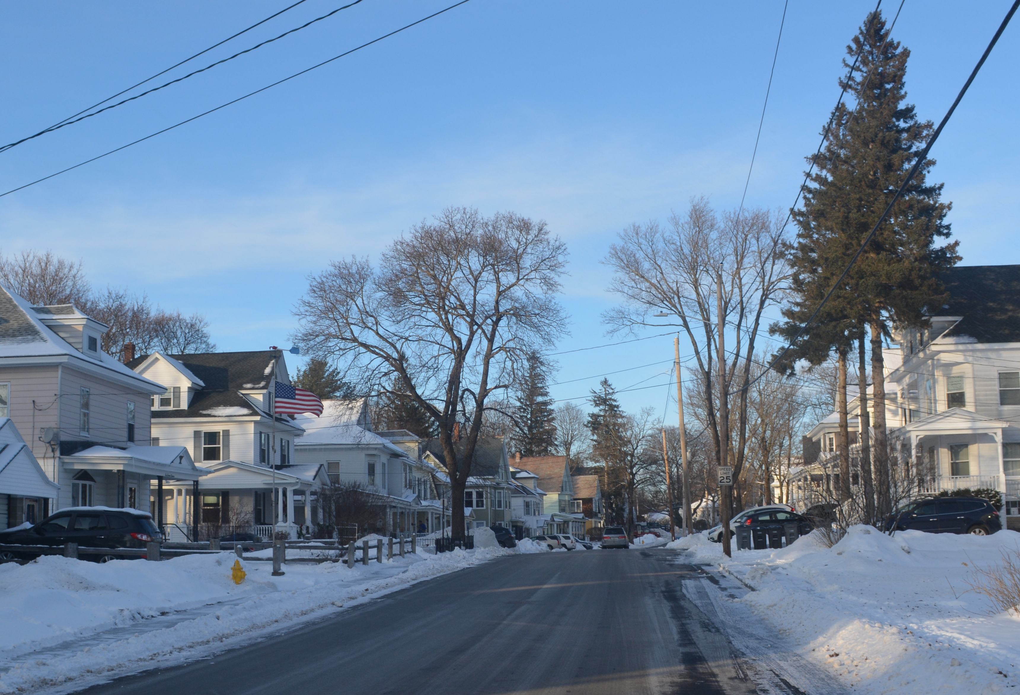
Public shade trees in a Gardner neighborhood
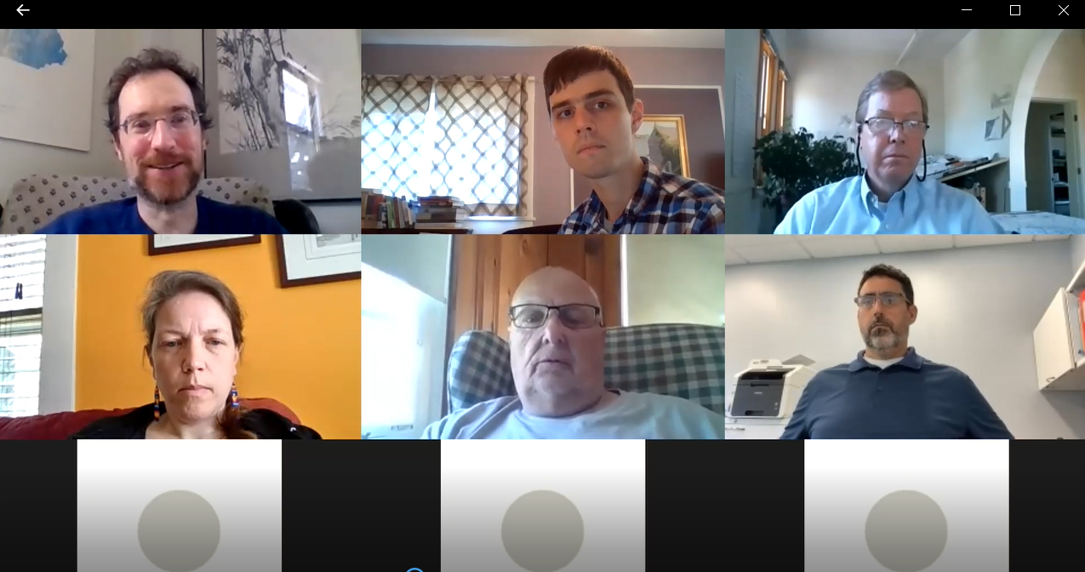
The Community Resilience Building workshop was held as a series of online Zoom meetings since in-person workshops were not possible during the COVID-19 pandemic. Breakout groups were still possible in online meetings. (Source: Dodson & Flinker)
Meanwhile, the core team and the consultants prepared for the Community Resilience Building (CRB) workshop—a full day invitation only workshop which is the heart of the MVP planning process. The workshop can take place as one long session or as a series of shorter workshops. In this case, the global COVID-19 pandemic made in-person large gatherings impossible, so the team agreed on a series of online workshops using Zoom. In preparation, the project team gathered background information, developed a schedule and agenda for the workshop, and recruited a group of invited stakeholders. Stakeholders were selected to represent a variety of City departments, boards, and committees, as well as local businesses, regional organizations, and vulnerable populations. See the full list of participants at the end of this report.
The Community Resilience Building (CRB) workshops were held on April 29, May 6, and May 13, 2020. The workshops followed a community-driven planning process that has been tested and refined in dozens of communities throughout Massachusetts and beyond (see the CRB Workshop guide available at www.communityresiliencebuilding.com).
The workshop’s central objectives were to:
- Define top local natural and climate-related hazards of concern
- Identify existing and future strengths and vulnerabilities
- Develop prioritized actions for the community
- Identify immediate opportunities to collaboratively advance actions to increase resilience.
The first workshop began with a presentation that explained the workshop process and terminology, gave background information on climate change including watershed-level projections of climate change in Massachusetts, described past climate-related natural hazard events in Gardner, and provided background information about Gardner’s infrastructural, societal, and environmental strengths and vulnerabilities. See the Appendix for the full presentation. The presentation was followed by a group discussion of how climate change might influence natural hazards in Gardner and which hazards would be most important to evaluate. For the next hour, participants worked to identify Gardner’s top hazards using an online mapping application.
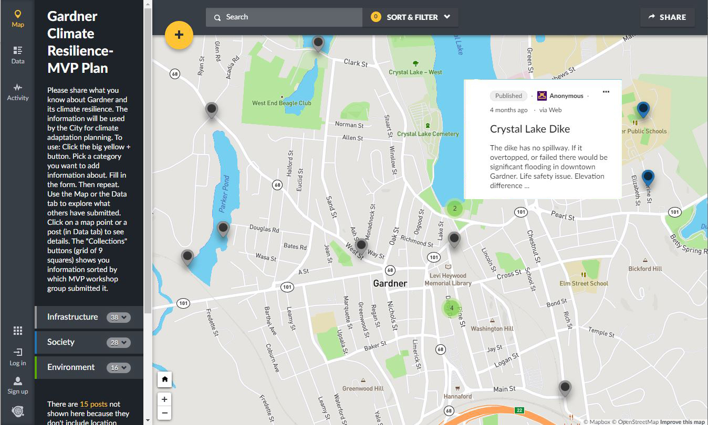
Online interactive map used during Gardner’s MVP Workshop to gather informatin about Gardner’s strengths, vulnerabilities and potential actions
After the first workshop, participants were asked to complete homework, identifying important infrastructural, societal, and environmental features on a collaborative online mapping platform. The locations of specific features could be pinned on the map, along with any associated notes. Features that were non-location specific could be added as well.
During the second workshop, participants discussed the strengths and vulnerabilities that they had started to identify, and added others using the shared online map. After the second workshop, participants were again asked to complete a small “homework assignment” by thinking of their personal top action items or highest priority issues that should be identified through this project. Participants were also given the opportunity to add any final items to the shared online map, and to review and give input to the in-progress MVP matrix which was in a shared online spreadsheet.
The third online workshop began with a presentation about how to craft effective actions for building local resilience, in the short term under current climate change predictions, with a focus on nature-based solutions (see the Appendix). Workshop participants then worked in small groups to brainstorm and prioritize actions that could build on Gardner’s strengths or mitigate its vulnerabilities, in the short term under current climate change predictions, to the top climate change related natural hazards identified by the group.
At the end of the third workshop, the full group assembled again. Each small group shared their priority actions, as facilitators summarized them on moveable “stickies” on a shared screen with the Stickies.io app open. Actions could then be arranged on screen and grouped into categories. The full group discussed the priority actions and by the conclusion of the meeting had agreed upon a ranking of the top five actions.
The top actions were reviewed and further refined during a meeting of the Core Team on July 7, 2020.
This report captures the wealth of information and ideas that were generated during the CRB workshop. It highlights the top hazards, the key infrastructural, societal, and environmental vulnerabilities and strengths identified by workshop participants, and the key actions that Gardner could take to build on its strengths and, to the extent feasible, reduce its vulnerabilities.
This report incorporates comments from the MVP core team and input from community members that attended a virtual listening session held on ___________, 2020 or provided comments on the public review draft which was posted on the City’s website.

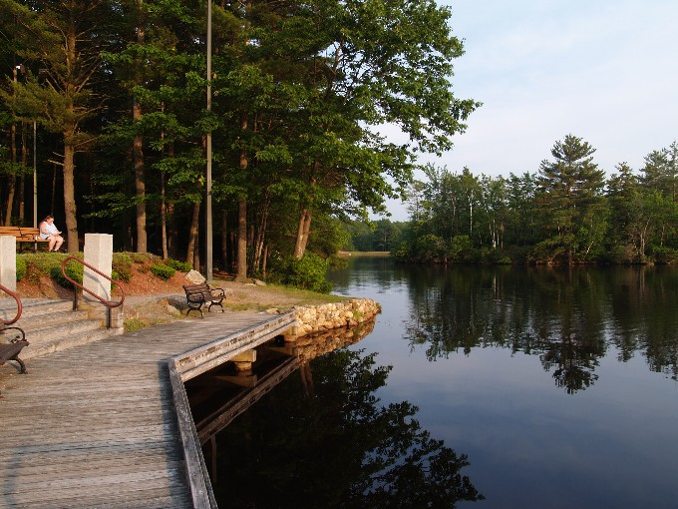
Dunn Pond, Dunn State Park (Source: Wikimedia)

3. Top Hazards & Vulnerable Areas
Natural hazards are natural events that threaten lives, property, and other assets. Often, natural hazards can be predicted. They tend to occur repeatedly in the same geographical locations because they are related to weather patterns or physical characteristics of an area.
The Montachusett Hazard Mitigation Plan 2015 Update is Gardner’s most recent approved hazard mitigation plan. The 2015 regional hazard mitigation plan evaluated Gardner’s risk from various hazards. Its findings are listed below.
Hazards According to Montachusett Hazard Mitigation Plan 2015
High Risk Hazards:
- Heavy rain, severe thunderstorms, and associated flooding
- Winter storms (nor’easters, heavy snow, ice storms, blizzards) and ice jams
- Major urban fires
- Flooding from beaver dams
Moderate Risk Hazards:
- Snow melt
- Dam failure
- High winds
- Hurricanes
- Tornados
- Drought
- Extreme temperatures
Low Risk
- Wildland fire
- Earthquakes
- Landslides

The hazard risk evaluation above was the starting point for the assessment of hazards at the MVP workshop. It was augmented by climate change projections provided by the MVP program, information from the Massachusetts Integrated State Hazard Mitigation and Climate Adaptation Plan about climate change and its interactions with natural hazards, and the knowledge, wisdom and experience of Gardner’s staff and citizens who participated in the process.
At the CRB workshop, the group identified the following as top hazards that Gardner faces:
- Flooding
- Severe storms (storms in all seasons)
- Ecosystem Disruption
- Average and Extreme Temperatures and Drought
Priority Climate-Related Hazards for MVP Planning

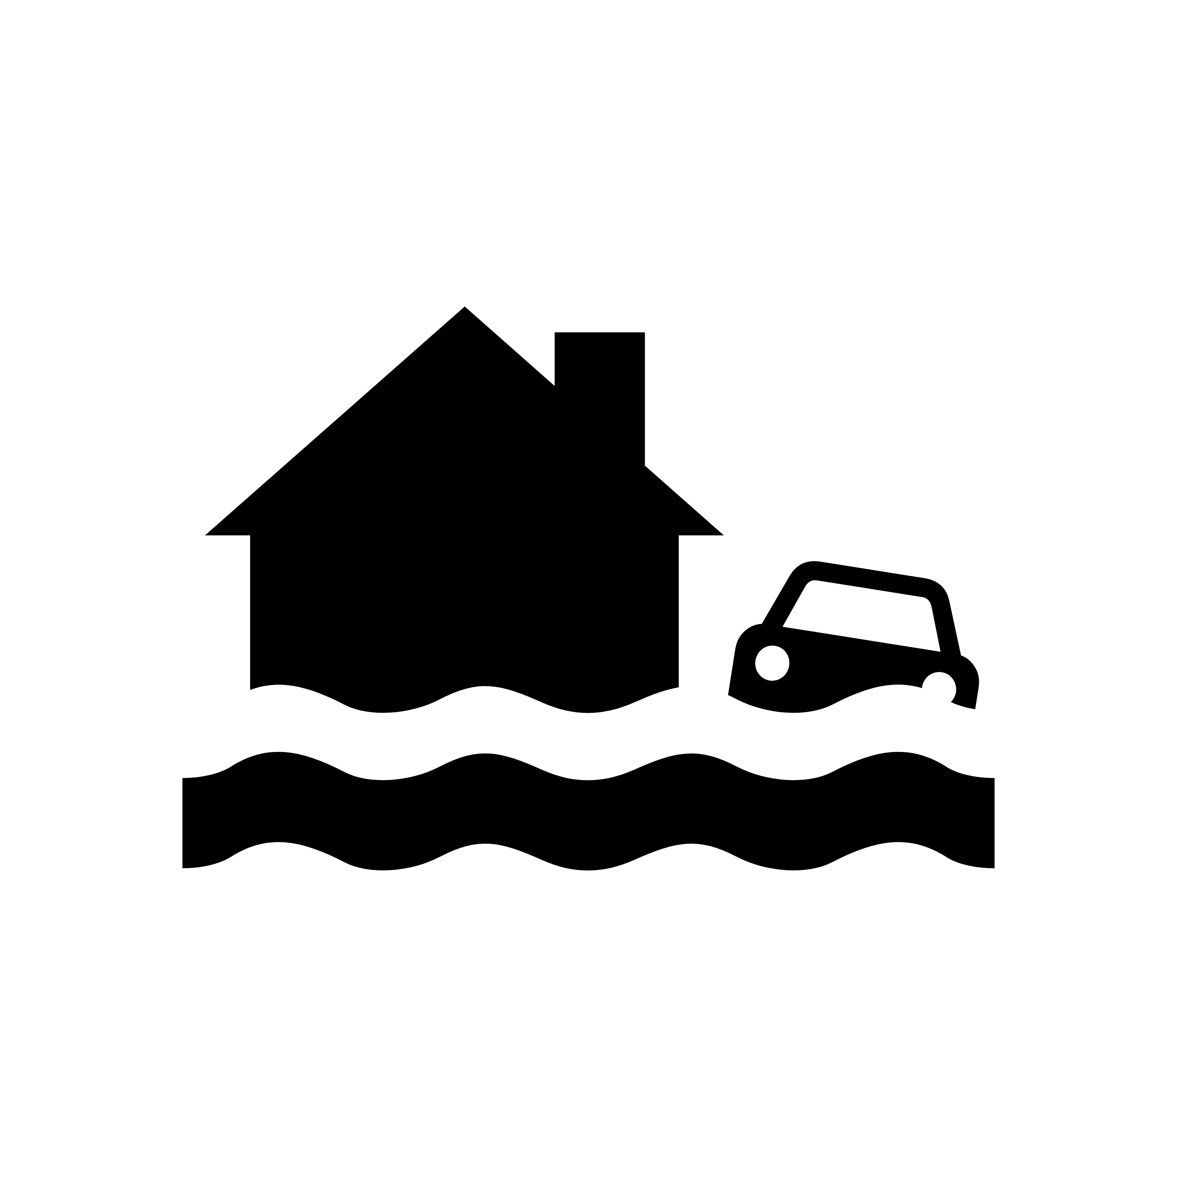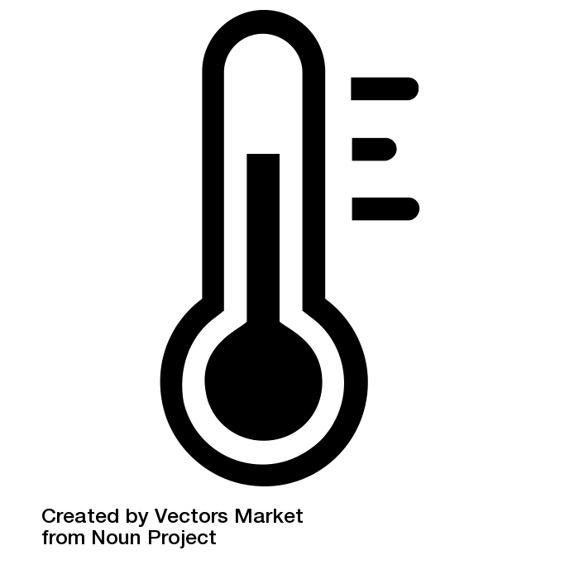

Flooding, Severe Storms, Ecosystem Change, and Average and Extreme Temperatures and Drought are the city’s top climate-related natural hazards according to participants in Gardner’s MVP Workshop
(Sources, left to right: Flood by Iconathon US from Noun Project, Storm by Alexis from the Noun Project, Tree by Liane Kirschner from the Noun Project, Temperature by Vectors Market from Noun Project)

Areas of Concern (Specific Locations)
Workshop groups mapped specific locations where natural hazards are particularly problematic. The marked-up maps are included in the Appendix to this report. Specific areas of concern include:
- Crystal Lake dike, which has no spillway and sits immediately uphill from Main St.
- Various smaller dams, including Ramsdall Dam, Hilchey Pond Dam, Wrights Earth Dam, Bents Pond Dam, Parkers Pond Dam, Wayside Pond Dam, Mahoney Brook Dam, Travers Dam, Perley Brook Dam
- Roads that may flood due to undersized culverts: Whitney Street, Chestnut and Main St / Union Square, Parker/ Ash/ Monadnock Streets. Bailey Brook Bridge over Clark Street, Century Way culverts, Bridge Street, airport access road, Keyes Rd, Century Way
- North Central Correctional Institute, a state-operated prison located in Gardner
- Sludge landfill, whose on-site stormwater system may be threatened by increasing storms
- Priority areas for conservation and restoration including large, undeveloped tracks of land within Water Supply Protection Area, and undeveloped areas of wetland with flood control potential.
- Areas of beaver activity with potential to flood roads or other infrastructure
- Olde English Village, a low-income population farther from downtown resources
- Heritage Village, a 55+ community with only one entrance that’s prone to flooding
- High School and Middle School, facilities that have AC window units which may not be adequate as summer season extends
- Cooling shelter is currently small (in a restaurant) and not well-known
- Mount Wachusett Community College

4. Current Concerns and Challenges Presented By Hazards and Climate Change

Projected Changes in Gardner’s Climate

To prepare for the future, Gardner needs to know how the area’s climate may change over the coming decades and how that will impact natural hazards. The workshop built on the following key information resources: The Montachusett Hazard Mitigation Plan 2015 Update, the 2018 Massachusetts State Hazard Mitigation and Climate Adaptation Plan, and “Massachusetts Climate Change Projections” by Northeast Climate Science Center at the University of Massachusetts.
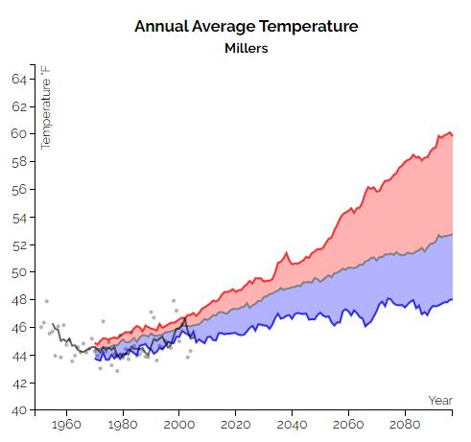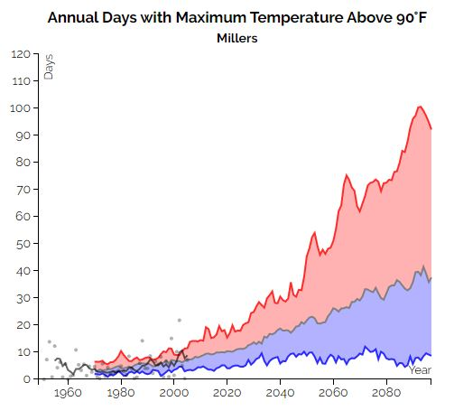
Climate Change Projections for the Millers River Basin from the Northeast Climate Science Center at the University of Massachusetts (Source: Resilientma.org, http://resilientma.org/datagrapher/?c=Temp/basin/maxt/ANN/Millers/)
Although there is uncertainty about how rapidly the climate will change over the coming decades or how extreme the results will be, we do know the general direction of climate change. From that we can generally predict how climate change will influence natural hazards. We know that annual air temperatures in the Northeast have been warming at an average rate of 0.5°F (nearly 0.26°C) per decade since 1970. Winter temperatures have been rising at a faster rate of 0.9°F per decade on average. The increases in temperature are projected to accelerate over the coming decades. Climate projections for the Millers River Watershed that were produced by the Northeast Climate Science Center at the University of Massachusetts predict that by the 2050s:
- Average annual temperature will rise 5.4°F (4-26%)
- Average winter temperatures will rise from 23° to 29°
- There will be significantly fewer days below freezing per year (19-35 fewer days)
- The biggest increases in precipitation will happen in winter, but with less snow (1-21% more inches of precipitation).
Along with higher average temperatures there will also be more extremely hot days. By mid-century, Gardner may experience the following increases in extremely hot days:
- Days Over 90°F: from 4 days to 12-34 days per year
- Days Over 95°F: From <1 day to up to 13 days per year
- 16-74 more days over 90° per year by end of century

Extremely hot days can cause heat stress, especially for children, older adults, and those with chronic health conditions. Heat waves can be extremely dangerous and result in more deaths than cold snaps. Extreme heat can result in blackouts, stress pavement on the city’s roads, contribute to forest fire risk. Meanwhile, overall warmer temperatures can stress numerous species that have adapted to cooler conditions and can increase the prevalence of invasive species and vector-borne diseases which can devastate ecosystems and human health.
With climate change, more annual precipitation is expected, with a 2-13% increase in precipitation by mid-century. Precipitation patterns will also shift across the seasons. Gardner’s winters will see the greatest increase (1%-21%) in precipitation—though with less snow. Precipitation in summer and fall could increase or decrease. Likewise, drought may increase or decrease. Overall, more precipitation will fall in large events.
Overall, changes in temperature and precipitation patterns will continue to disrupt the relatively stable and hospitable climate that Gardner’s residents, plants, and animals have historically enjoyed. Although New Englanders like to complain about the weather, we know how to deal with minor snowstorms and our summers are relatively bearable. In the coming decades, as in recent decades, Gardner will continue to experience increasingly unpredictable and extreme weather patterns.
Winter may bring more crippling snowstorms, more ice storms, winter flooding due to rapid thaws or rain on frozen ground, and decreased snowpack. These changes will impact daily life, the lifecycle of plants and animals, stream flow, water levels in lakes and reservoirs, groundwater recharge, and drinking water supplies, etc.
Spring, summer, and fall may bring more extreme temperatures, larger and more frequent tropical storms and hurricanes, thunderstorms, tornados, and microbursts. These larger storm events may exceed the design-capacity of some of Gardner’s road and stormwater infrastructure which were designed for more moderate events. For houses on septic systems, episodes of elevated ground water levels could inundate leach fields or cause septic tanks to ‘float’.
Already, some other communities have decided to consider the 500-year flood plain the new 100-year flood plain. Larger storm events may result in erosion and may reduce the ability of natural systems to cleanse and infiltrate stormwater which could reduce aquifer recharge and impact water quality.

Impacts of Climate Change on Hazards in Gardner
The City of Gardner has been impacted by many natural hazards over the years. Winter storms have had a particularly severe impact. From 1996 to 2016 the Montachusett region experienced 11 winter storms that were federally declared disasters. The particularly severe ice storm in December of 2008 left the entire region coated in a heavy layer of ice, which downed countless trees leading to widespread and extended power outages. Given the cold weather, lack of heat quickly became a widespread problem. Many Gardner residents were forced to take refuge in the City’s emergency shelters, or temporarily leave the region if they could, until infrastructure was restored. The damage was so extensive that it took over a week to restore much of the region’s infrastructure. Previously unusual weather patterns, which can lead to unpredictable and severe events like the 2008 ice storm, will become increasingly common as the region’s climate changes.
Workshop discussions about the impact of climate change on hazards in Gardner recognized both the potential impacts on the urban portion of Gardner—with harm to human lives, properties, and infrastructure—and impacts on the city’s natural systems—with harm to forests, water systems, ecosystems, etc. Workshop participants also recognized that there are feedback loops between built and natural systems that could exacerbate harm to both.
On the human side, discussion of impacts to community members from identified hazards largely focused on roads, culverts, dams, flooding, and storms. Residents are concerned that Crystal Lake, whose dike is perched just uphill of Gardner’s Main St, has no emergency spillway and therefore poses a major threat to all of downtown Gardner if the dam were to spill over or fail during a major rainstorm. Residents also want to ensure that Gardner’s compact downtown continues to evolve as a resilient environment in the face of climate change. While residents can already walk to access many basic resources within downtown, enhancing the city’s urban forest and pedestrian networks will help make downtown Gardner both more livable and climate-resilient.
Workshop participants highly value Gardner’s environment, its water bodies, forests, ecosystems, and biodiversity. While Gardner does have a fairly extensive pattern of protected land surrounding its dense urban core, participants pointed out priority areas for additional land conservation that would better connect hydrological and ecological systems to control flooding, protect water quality, and support biodiversity. Participants are concerned about the possibility that changing temperature and precipitation patterns, combined with invasive species and pests will result in wide-spread forest dieback, including in certain areas that were planted as red pine monocultures earlier in the 20th century. Forest dieback could, in turn, lead to forest fires, erosion, and more rapid movement of water into streams and rivers, lakes, ponds and impoundments exacerbating flooding and degrading water quality. Likewise, warming and changing precipitation patterns threaten Gardner’s water resources.

Key Hazards

Flooding: Flooding was cited as a top concern by workshop participants. Flooding will predominantly impact roads, especially at road-stream crossings. Flooding can also damage homes and businesses, dislocate people, increase water contamination and water-borne illnesses, and result in illness from mold exposure after flood waters recede., The risk of Crystal Lake overtopping in a large storm may be the most severe potential flood risk in Gardner. The network of open spaces and wetlands surrounding Gardner’s urban core can help mitigate the severity of floods.

Severe storms (all seasons): Between 1958-2012, the Northeast experienced a 71% increase in precipitation that falls as part of a heavy precipitation event. Severe storms create the risk of flood events, as highlighted above. They also can cause: falling or flying objects—resulting in injuries and damage to property; damage to roads—resulting in motor vehicle accidents and delayed emergency response; damage to water and sewer/septic infrastructure—resulting in water contamination and water-borne illnesses; and power outages—resulting in increased falls and injuries in homes, carbon monoxide poisoning from improper use of generators or heating devices, and loss of power to life-sustaining medical devices. Gardner residents experienced widespread power outages and associated loss of heating and other infrastructure for over a week during the ice storm of December 2008. Severe storms are particularly threatening to the elderly, people living alone, people with limited mobility, people with limited English proficiency, people with chronic diseases, or compromised immune systems, children under five years old, and people who use electrically powered medical devices.

Average and Extreme Temperatures, Drought: Current trends indicate that the climate in New England is steadily warming, with more extremes in both rainfall and drought. On average, the Northeast experienced 10 more frost-free winter days between 1991-2012 than it did from 1901-1960. Current trends indicate there will be increasingly more days per year above 90 in the coming decades. Older adults, children, and people with low incomes are especially vulnerable to heat related illness and death, including heat stroke, dehydration, aggravated cardiovascular disease, and aggravated respiratory disease.

Ecosystem Disruption: Gardner is fortunate to have large areas of forest, wetlands, and water bodies, that provide wildlife habitat, ecosystem services, recreational opportunities, and quality of life benefits within easy reach of its walkable urban center. Changing temperature and precipitation patterns may stress or degrade these ecosystems. Climate change may worsen the impact of pests, such as the Hemlock Woolly Adelgid and, Emerald Ash Borer, and blights, such as beech bark disease. Heat and drought will stress numerous plant species and wildlife. In addition, heightened storm frequency and intensity increases the potential for destructive wind or ice storms to damage trees. Broadscale change in Gardner’s ecosystems would threaten numerous native species and key qualities that make the city what it is. Direct impacts on humans include the potential for increased risk of vector borne illness, fires, and infrastructure damage from weakened or downed trees.
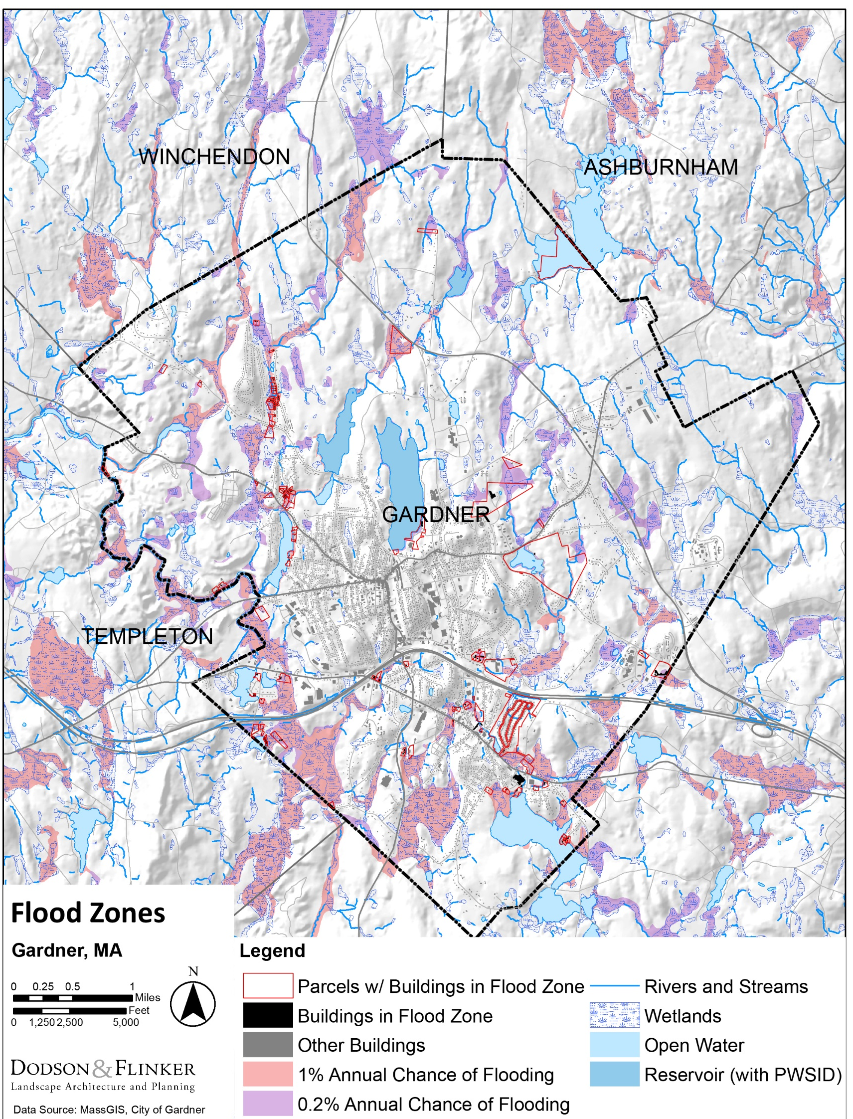
Map of FEMA Flood Zones. The map highlights buildings and parcels that are at least partially located in designated flood zones.

5. Specific Categories of Concerns and Challenges

Infrastructural Vulnerabilities
Roads, Sidewalks, Paved Areas
Climate change could damage roads through the following: larger storm events could cause road erosion, washouts, and blockages and damage from downed trees and power lines; increased erosion due to rain that follow periods of drought (rain on dry soil is more likely to run off than rain on moist soil); more frequent freeze-thaw cycles; extreme heat can soften asphalt leading to rutting and subsidence.
- There are numerous locations where low-lying roads or undersized culverts risk road flooding. Examples include:
  - Lower Whitney St in south Gardner, a low area of road adjacent to a marsh and stream.
  - The area where West, Ash and Monadnock Streets meet could be flooded if a rain event exceeds culvert capacity.
  - The area where Chestnut and Main Streets meet, also called Union Square, could be at risk of road flooding and washouts.
  - Waterview Drive is the only road access to Heritage Village with a low stream crossing within the 100-year floodplain.
  - Manca Drive is the only road access to Olde English Village, with a crossing over Pond Brook.
  - Route 2A outside of downtown Gardner is adjacent to a large wetland and has flooded in the past.
  - Forest cart roads for wildfire protection should be maintained for fighting and preventing wildfire in critically important water supply protection forests.
  - The access road to Gardner Municipal Airport passes through wetlands and floodplains. The airport is owned by the City of Gardner, but is located in Templeton.
- Downtown Gardner has a high percentage of impervious surfaces from roads, buildings, and parking areas. This makes the area hotter than other parts of the City and will exacerbate the impacts of extreme heat on downtown residents and visitors. The impervious surfaces also speed the movement of water, resulting in more rapid flooding and loss of aquifer recharge.

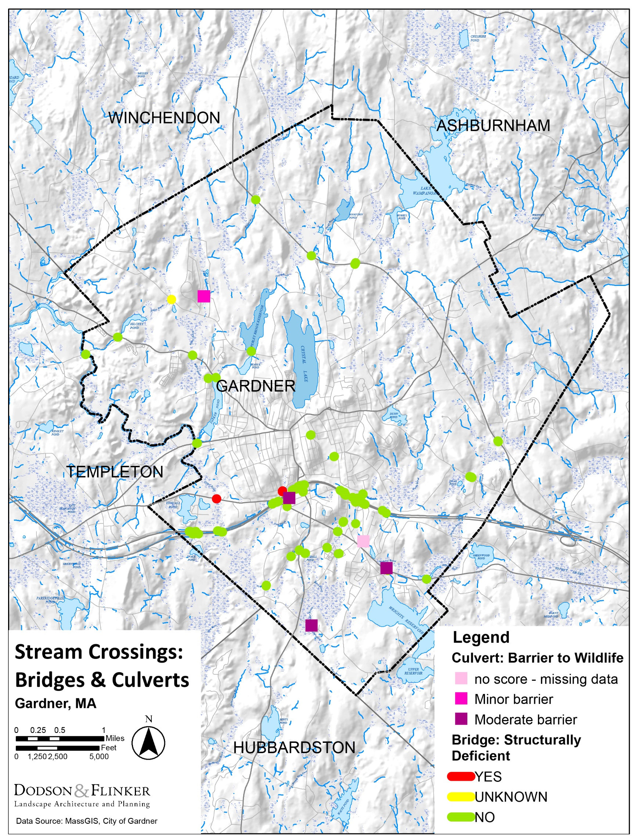
Map of known culverts and bridges in Gardner

Road-Stream Crossings (Bridges and Culverts)
Climate change will impact culvert and bridges through large storm events that have the potential to scour or damage bridge piers and abutments, to overtop bridges, or to lift bridges off their piers. In addition, many existing culverts in Gardner, like the rest of the state, are undersized. When a culvert cannot adequately pass the required flow of water, either because the culvert is undersized, blocked by an ice dam, or clogged with debris, water can overtop the road leading to washouts and road closures. In addition to disrupting transportation, when roads wash out the resulting sediment degrades downstream habitat. There is also some evidence that climate change may accelerate degradation of materials used in bridges and culverts including steel and concrete. In addition, banks adjacent to bridges and culverts may erode faster and possibly fail due to faster stream velocities and the loss of bank stabilizing vegetation.,

Gardner’s primary bridge/culvert vulnerabilities include:
- Keyes Road is the only access to a small neighborhood, and its culvert may be in need of upgrading.
- Century Way culverts which are often being blocked by beaver activity.
- Bridge Street at Bailey Brook crossing has undersized culverts.
- Many of the roads listed in the “Roads” section above may have flooding vulnerability directly due to the sizing of their culverts.
- When prioritizing culverts for upgrades, the City can also consider whether the upgrade will have other benefits. One potential benefit is reducing barriers to movement of wildlife. Of the dozens of culverts in Gardner, four have been evaluated for wildlife impacts. Three are a moderate barrier and one is a moderate barrier.

Dams and Flood Control
There are at least twenty dams in the City, according to MassGIS data. Ten are owned by the City of Gardner, seven are privately owned, and two are owned by the Massachusetts Department of Conservation and Recreation. Massachusetts Office of Dam Safety is responsible for maintaining records on jurisdictional dams statewide to ensure that best practices related to inspection, maintenance, and emergency planning are followed by dam owners. The Office of Dam Safety assigns a hazard potential rating for each dam. This rating indicates how likely failure of the dam would lead to loss of life, damage to property, or interruption of important services—it does not indicate whether a dam is likely to fail (i.e. it is not based on structural integrity). All owners of jurisdictional dams are required to have their dam regularly inspected by a qualified engineer. The required interval for the inspection varies by the dam’s hazard potential: every two years for a high hazard potential dam, every five years for a significant hazard potential dam, and every ten years for a low hazard potential dam. In addition, owners of high and significant hazard potential dams are required to annually submit an Emergency Action Plan to the Office of Dam Safety and any agencies who would be involved in emergency actions. Of the twenty dams in Gardner, eleven are rated as either moderate or high hazard level by the Office of Dam Safety. The high hazard dams are Cowee Pond Dam, Perley Brook Reservoir Dam, and Wrights Reservoir Dam, which are owned by Gardner. While Crystal Lake Dike’s risk rating was not included in this ODS inventory, residents agree that its size, location above downtown, and lack of an emergency spillway are critical factors that combine to make this dam a top concern.
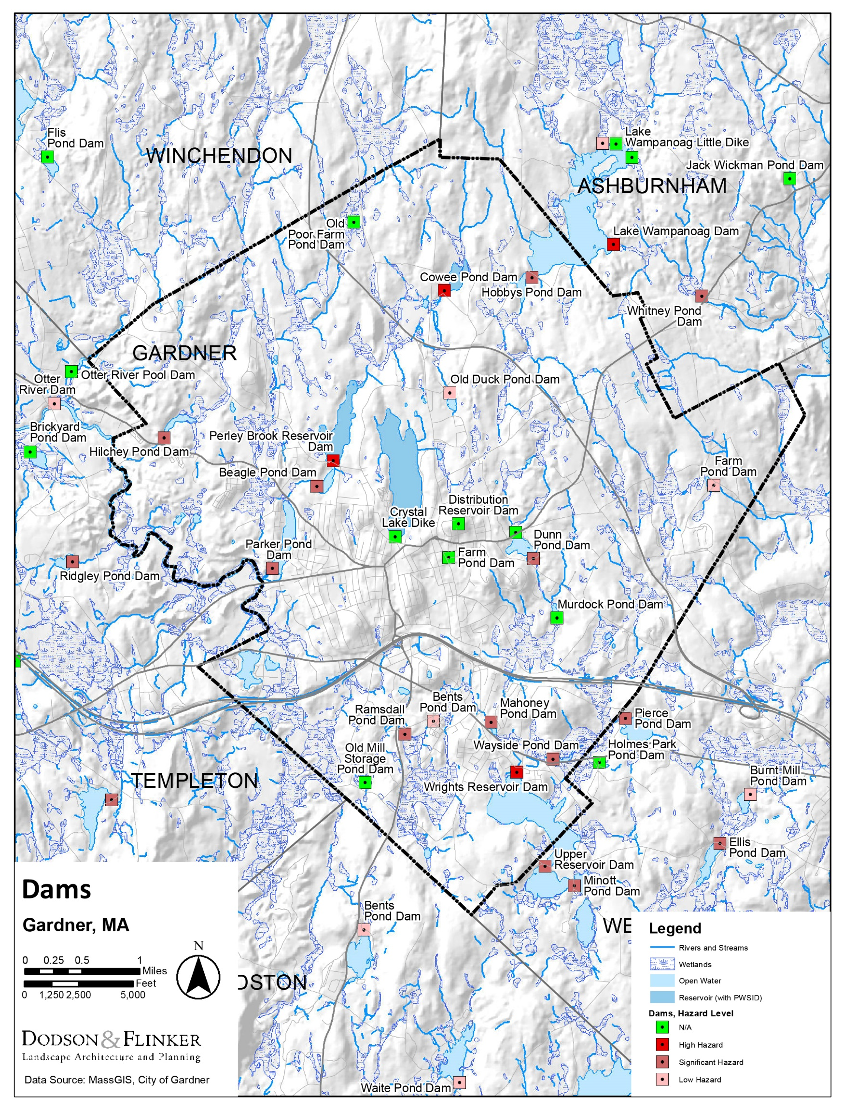
Map showing dams in Gardner symbolized by Hazard Potential rating
- Cowee Pond, Perley Brook Reservoir, and Wright’s Reservoir Dams are classified as high hazard potential dams. The classification indicates dams whose failure would likely cause loss of life and serious damage to homes, facilities, and/or roads. The “high hazard” classification does not indicate that a dam is structurally unsound.
- The US Army Corps of Engineers maintains a database of dams in the United States. Data for Massachusetts was last updated in 2018. At that time, there was no record of inspection for two of the dams rated low hazard: Bent’s Pond Dam, Old Duck Pond Dam. The database showed only three of the significant and high hazard dams had an Emergency Action Plan (EAP), which did not appear to be up to date (should be updated annually). There was no record of an EAP for the remainder.
- Workshop participants indicated that Hilchey Pond Dam and Ramsdall Dam may be in poor shape.
- Massachusetts Division of Ecological Restoration created an online mapping tool that estimates the potential ecological benefit of removing a dam. In the map below, each dam is color coded to show the relative potential benefit of its removal compared to other dams statewide (shown as percentiles). Hilchey Pond Dam is the highest-ranking dam in Gardner. It scores within the 90th percentile for dams statewide. Old Poor Farm Pond Dam, Cowee Pond Dam, and Hobbys Pond Dam all rank in the 75th percentile or higher statewide (higher rank equals more benefit). As mentioned previously, Cowee Pond Dam is also a high hazard dam, while Hilchey Pond Dam is a significant hazard dam.
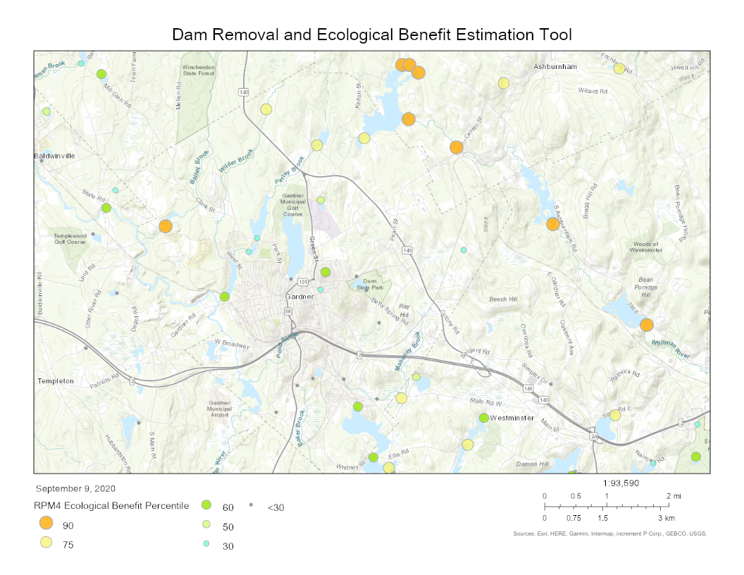
Map from the DER Dam Removal and Ecological Benefit Estimation Tool. It shows that removal of any of the dams in Gardner would have high benefits, especially Hilchey Pond Dam, Old Poor Farm Pond Dam, Cowee Pond Dam, and Hobbys Pond Dam. The mapping tool only considers potential ecological benefit and does not account for other variables which must be considered for dam removal.
Utilities
Utility (electricity, phone, internet, etc.) service interruptions typically result from storm damage or, in the case of electricity, from excessive demand (usually during hot periods). Both are likely to become more common with climate change.
- Most residents do not have a backup source of power, including those who rely on electricity for medical equipment or for refrigeration for medicines.
- Workshop participants did not identify any areas that are particularly vulnerable to utility interruption
- People with low incomes and people with medical devices are most vulnerable to utility interruptions.

Drinking Water and Stormwater
The City’s water supply comes from Crystal Lake and Perley Brook Reservoir both of which are adjacent to downtown and groundwater wells outside of downtown. Surface Water Protection Zone A restricts land use activity within a buffer zone around these resources, but there are some large tracts of land within these areas with no additional protection. Development in these areas would negatively impact water quality through surface runoff and septic leaching (since this area does not have sewer).
An overburdened stormwater system compromises the water quality of Parker’s Pond and the Otter River, with limited opportunities for infiltration and pretreatment. Increasing storm frequency and duration will further tax this system. Pond Brook runs underground through downtown Gardner, piped just east of the Main Street corridor beneath several buildings in this area. The condition and size of the pipe carrying this portion of the brook is unknown (it likely predates many of the buildings here). It emerges briefly to the surface before being piped again under Route 2, eventually merging with the Otter River. Along its piped course, Pond Brook receives a large amount of the City’s stormwater, carrying a large volume of water, sediment, and contamination to the Otter River.
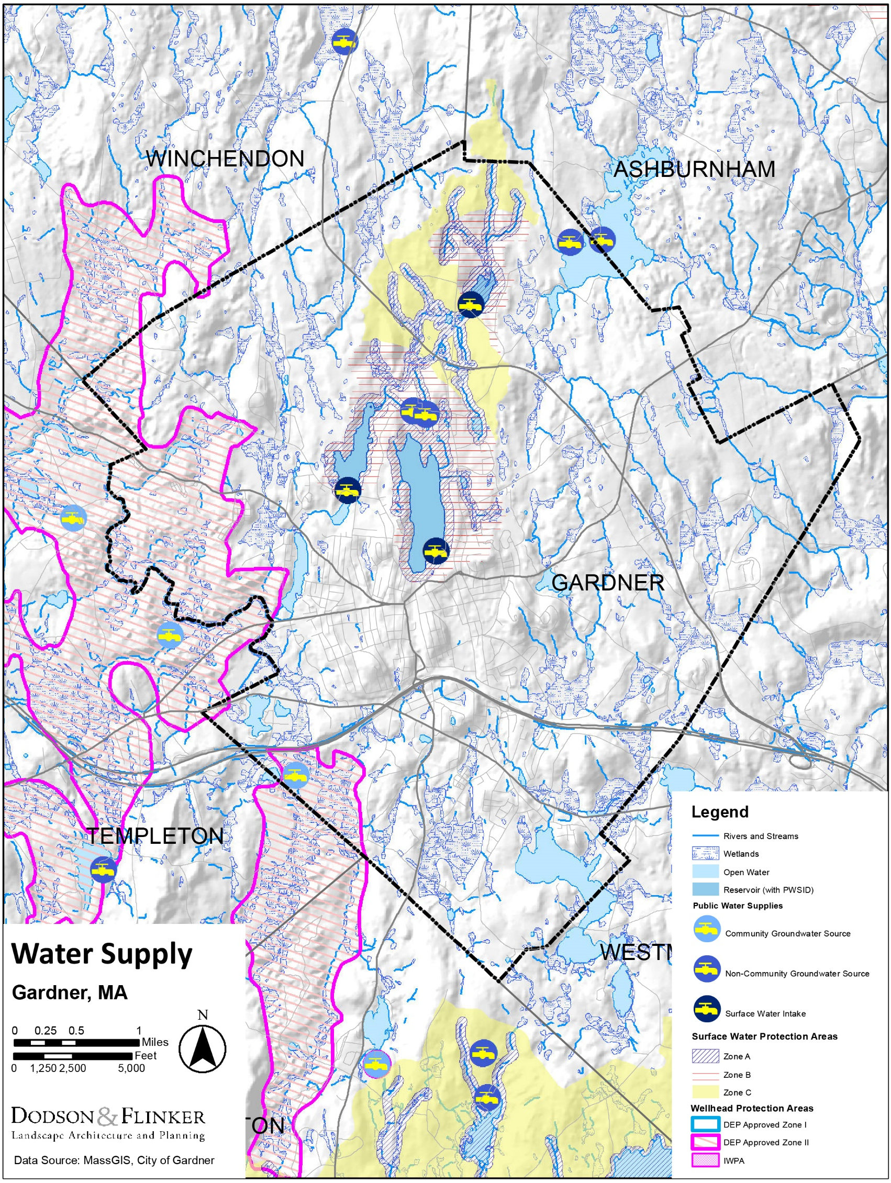
Map of Water Supplies, Infrastructure, and Protection Areas

Structures
- The impacts of flooding on structures is more predictable. There are no National Flood Insurance Program repetitive flood loss structures in Gardner according to data in the Massachusetts State Hazard Mitigation and Climate Adaptation Plan. Gardner has some structures that are built close to areas that could flood, but a majority of Gardner’s structures are above floodplains. According to GIS analysis conducted by Dodson & Flinker based on data from MassGIS, there are approximately 160 structures on about 119 different parcels (out of 6,658 total) in Gardner that are within the FEMA 100-year floodplain. This represents a very small percentage of Gardner’s buildings. However, this does not represent the totality of flood risk since the flood path from a potential dam failure at Crystal lake would severely impact most of the Main Street corridor and is a significant concern.
- Gardner has about 9,117 Housing Units. Of those units, 8,222 are occupied on a full-time basis, while 895 (about 10%) were vacant at the time of the American Community Survey (ACS), which is close to the statewide average. Of the occupied units, the ACS estimates that about 3,934 (48%) are renter-occupied and 4,288 (52%) are owner-occupied. The statewide average is 38% renter occupied and 62% owner-occupied.
- About 46% of housing was built before 1940. This implies that much of Gardner’s housing is not built to the building code standards of more modern housing in Massachusetts. Gardner’s older housing may be more easily damaged by natural hazards from climate change.
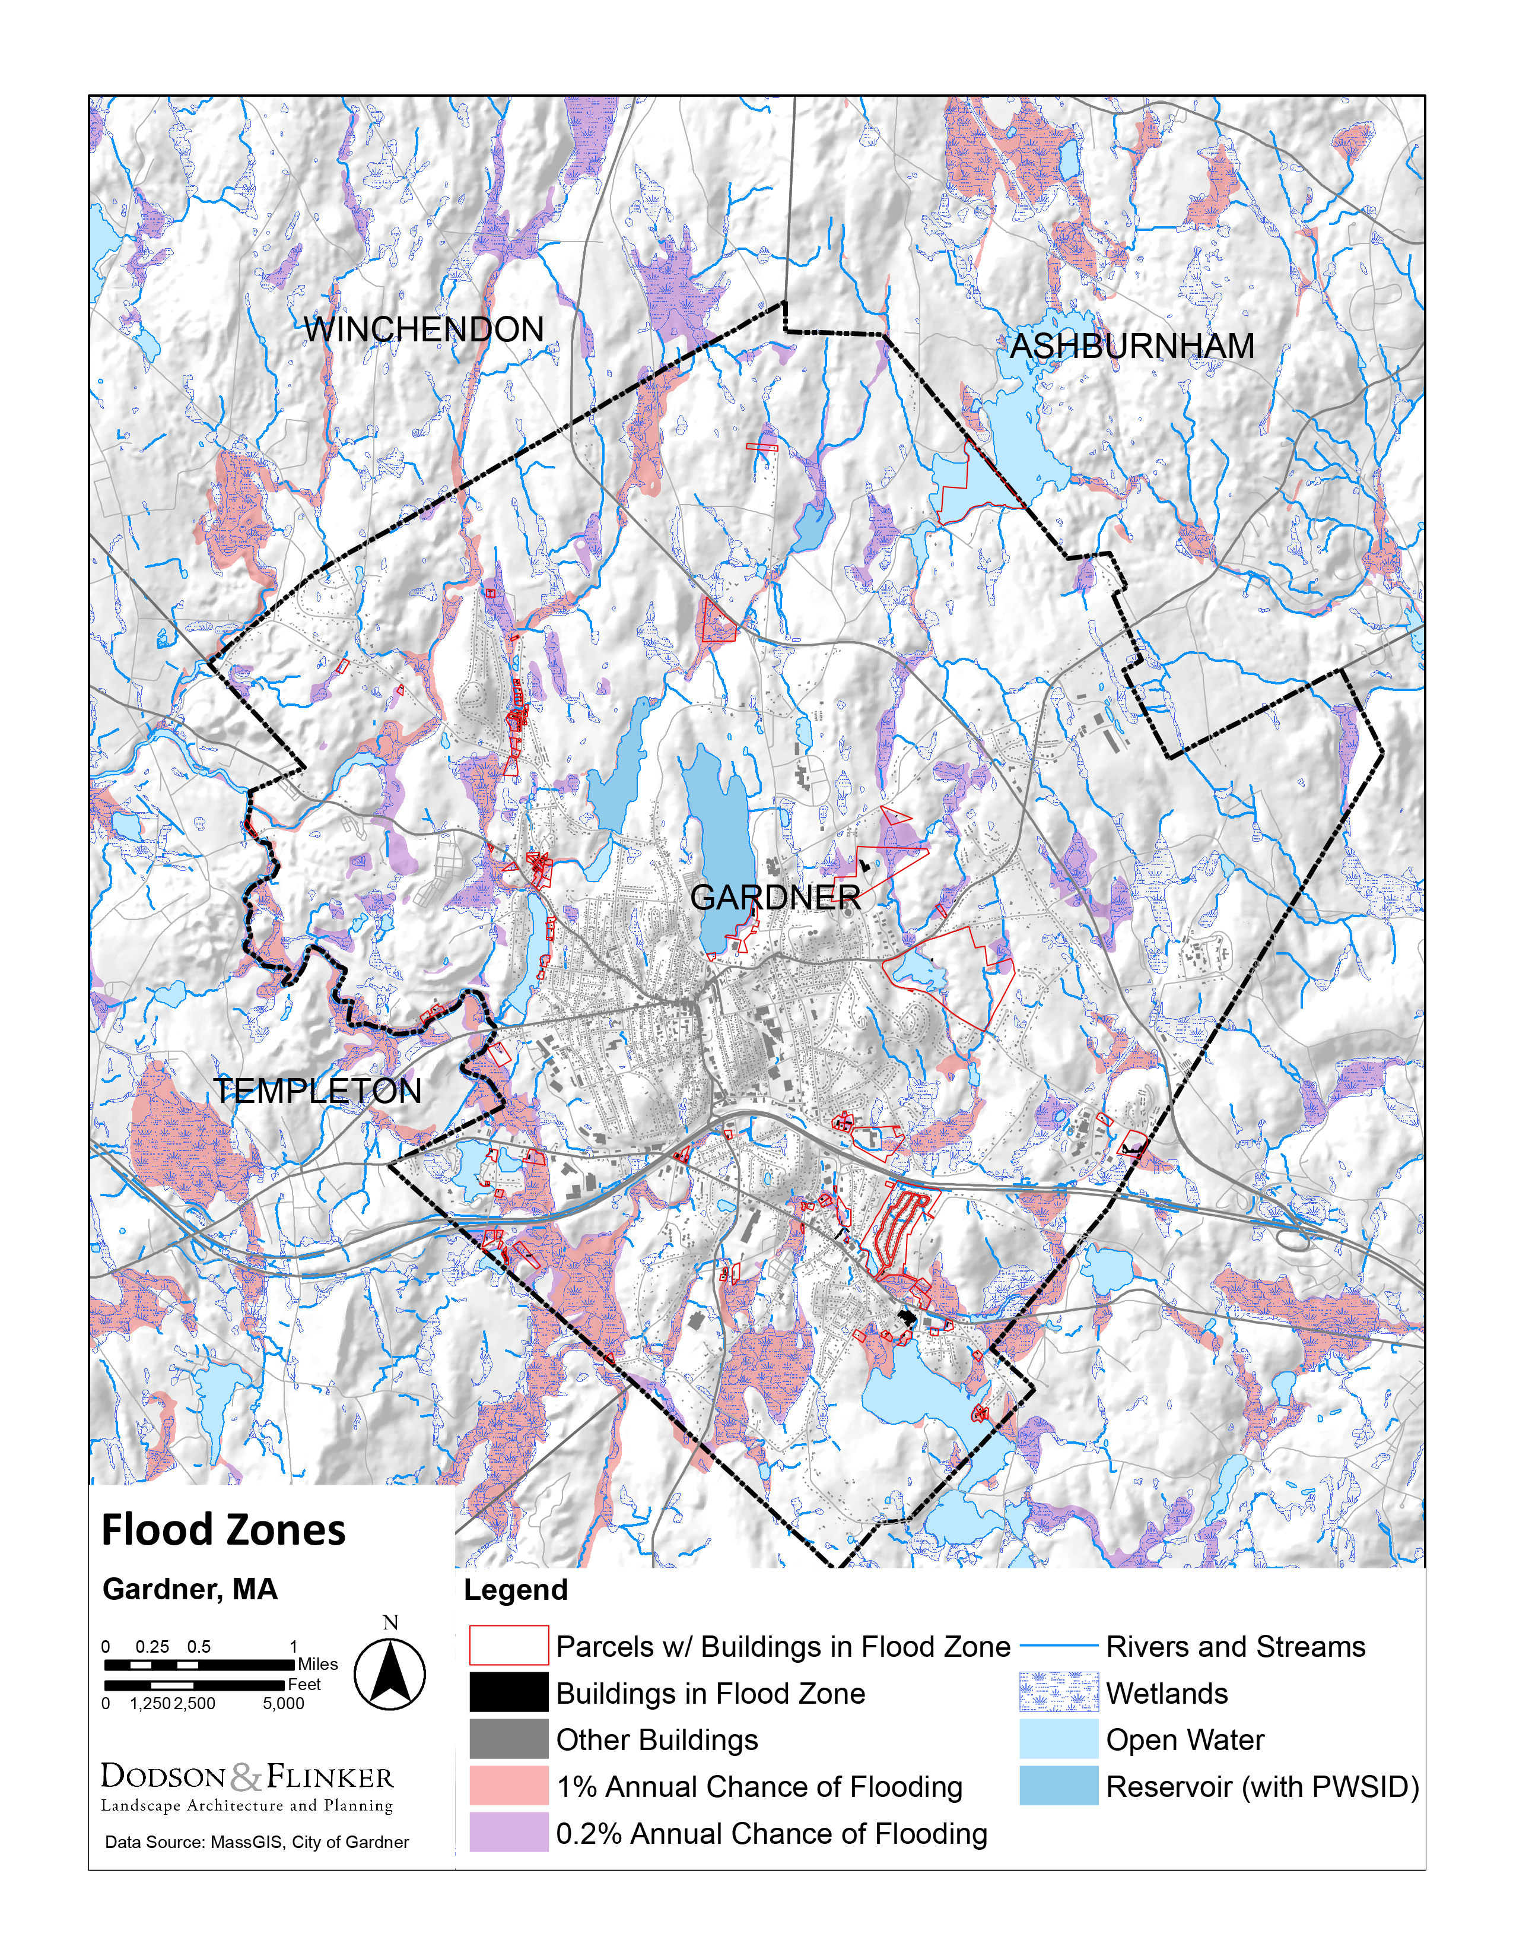
Map of Flood Zones highlighting structures and/or parcels that are at least partially in a flood zone.

Societal Vulnerabilities
The social aspects of a community shape its ability to prepare for and respond to natural hazards and climate change.
Vulnerable Populations
Climate change exacerbates existing social, economic, and health inequities. As a result of systemic inequalities, people with low incomes, especially black and Hispanic people, are more likely to live in areas that are in harm’s way from storms, floods, and environmental contamination. In addition, some people from these groups, as well as some children, some older adults, and some people with disabilities, have fewer resources to prepare for, and evacuate from natural hazards, when necessary. As result they experience heightened “mental, emotional and bodily stress due to natural disaster exposure.” Chronic diseases or other health problems can exacerbate harm from climate-related disasters. Limited English proficiency can also make people more vulnerable to climate related hazards.
- Gardner has a higher than state-average population under the poverty level. 15% of Gardner’s population is below the poverty level, compared with 10.8% statewide and 13% for Worcester County. Gardner’s median annual household income of $50,239 is well below the statewide median of $77,378.
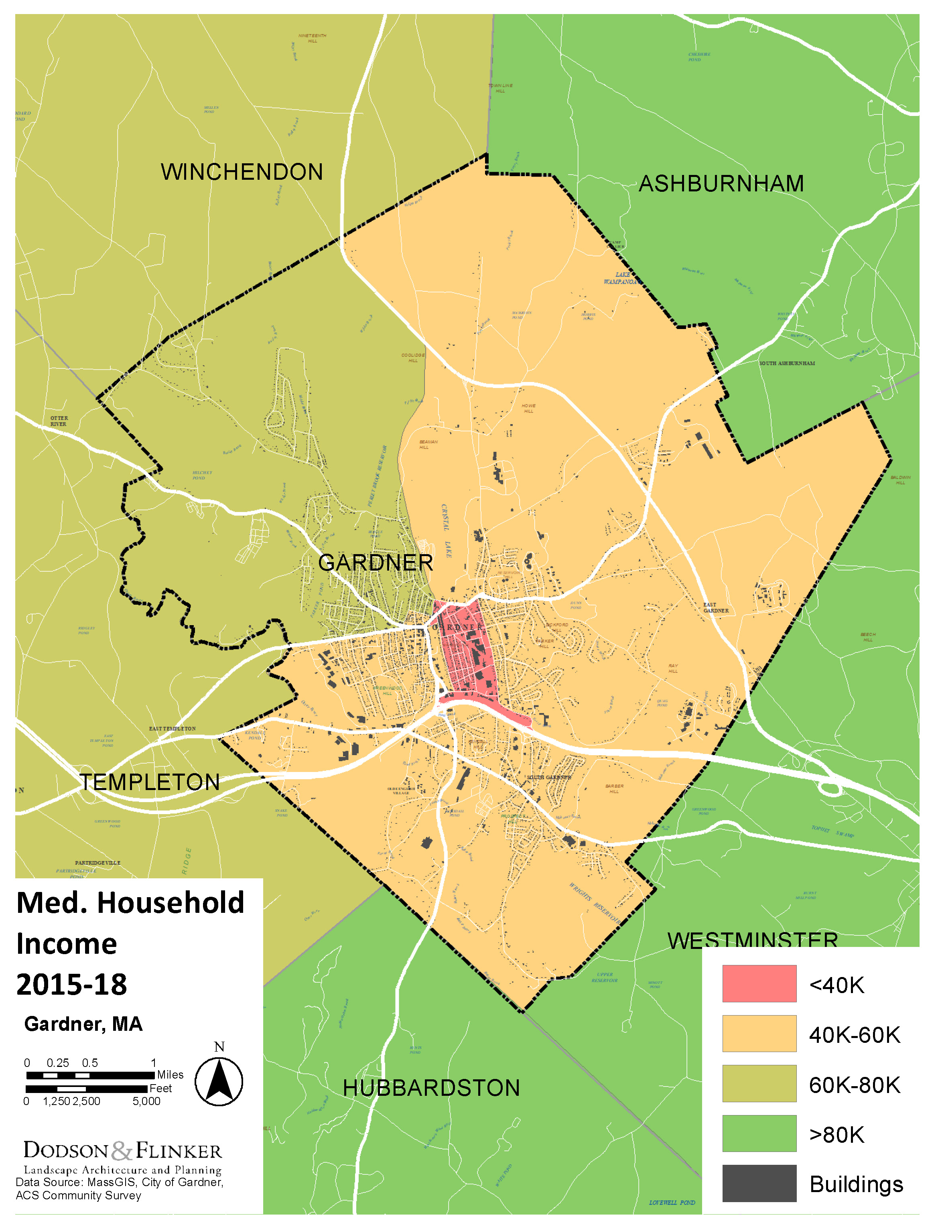
- The central portion of the city has the lowest median income and is designated as an Environmental Justice Area based on income. Residents of this area are less likely to have the resources to prepare for and respond to climate change. Workshop participants pointed to Olde English Village as another area with a concentration of people with low incomes that may be especially vulnerable to climate change—residents in this area may have lower access to resources in their immediate neighborhood than downtown residents.
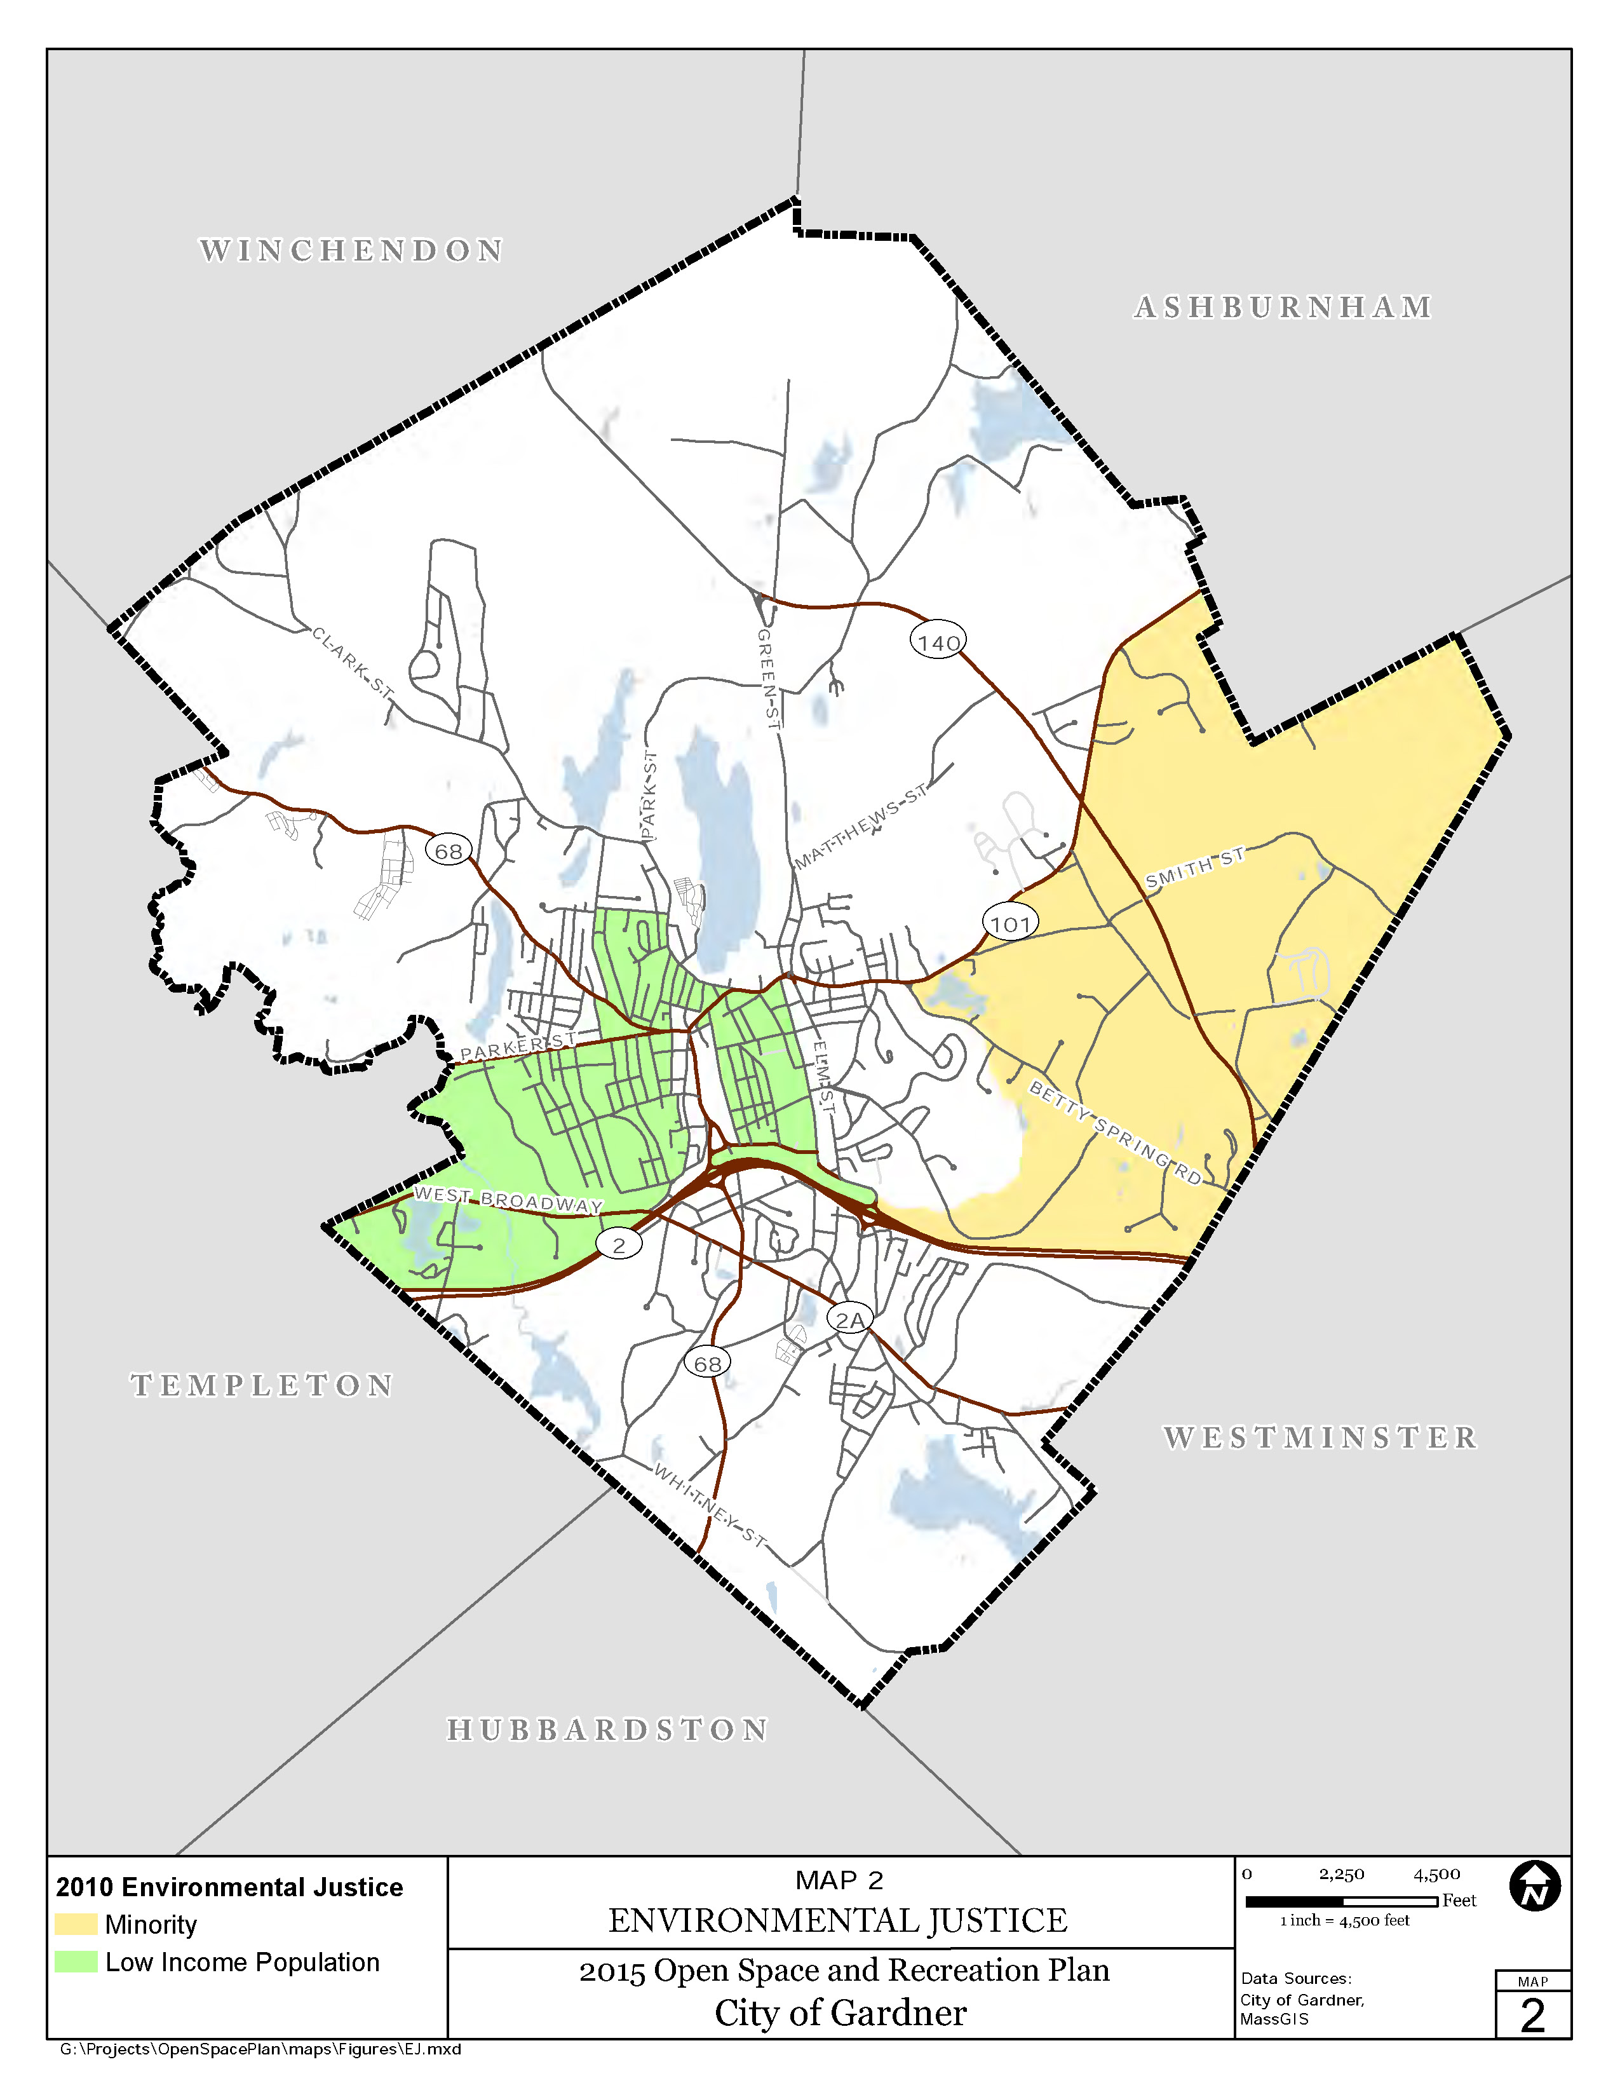
- Some of the eastern part of Gardner is designated as an Environmental Justice Area based on race (see map above). This is likely due largely to the population of North Central Correctional Institute which makes up nearly half of the population of the area shown on the previous map. This disparity reflects the history of systemic racism in the criminal justice system. Incarcerated populations have been cited as being particularly vulnerable to the effects of climate change, for example through exposure to extreme temperatures. While Gardner does not have jurisdiction over the Correctional Institute, it can nonetheless partner with it on climate change matters, for example by ensuring that evacuation routes are clearly defined and prioritized.
- Most of Gardner’s residents only speak English at home (90%) with 3% of residents speaking English “less than very well”, according to the US Census Bureau.
- Older Adults. 15.3% of Gardner’s residents are over age 65. In the coming decade, the older adult population in Gardner is expected grow, while other age groups shrink. Older adults, especially those with lower incomes, or who are socially isolated, or who have health issues will be especially vulnerable to climate change. Workshop participants were particularly concerned about Heritage Village—a 55+ residential development whose single access point is located in a 100-year floodplain. Residents of this development could be cut off from emergency services due to flooding.
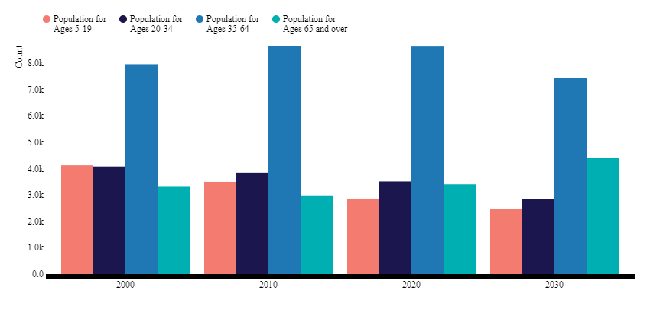
Source: Housing MA: The Massachusetts Housing Data Portal
- Children and Young People. Children, particularly those in low-income families, are vulnerable to the impacts of climate change, especially average and extreme temperatures. 20.2% of Gardner residents live in poverty—the highest poverty rate of any age group in the city.
- 13.6% of Gardner’s population have a disability. This is higher than the number for Worcester County (12%) or Massachusetts (11%).
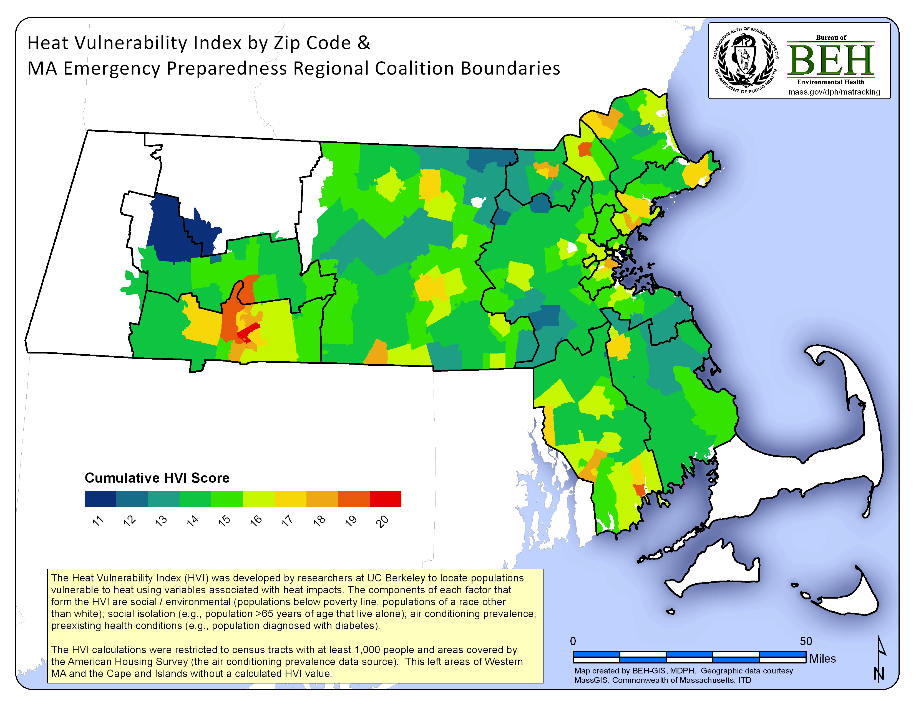
A map of heat vulnerability shows that Gardner is at greater risk than most communities in North Central Massachusetts. (Source: Bureau of Environmental Health, Massachusetts Department of Public Health)
- Overall, the population of Gardner is projected to grow slightly until 2030 and then to shrink back to approximately 2020 levels by 2040, according to UMass Donahue Institute. The Donahue Institute projections “assume that recent historical trends in migration, mortality, and fertility will persist in future years.” They do not include disruptions in current trends based on climate migration, the impacts of major economic upheavals, or other similar factors.

City Government/Emergency Response
- The City may not have adequate emergency shelters to serve its residents. The Senior Center is used as a cooling shelter but cannot handle a large volume of people. A local resident is also sometimes used but likewise has limited capacity.
- The High School and Middle Schools both rely on window air conditioning units for cooling. These units are inefficient and may be unable to sufficiently cool the spaces as temperatures rise.

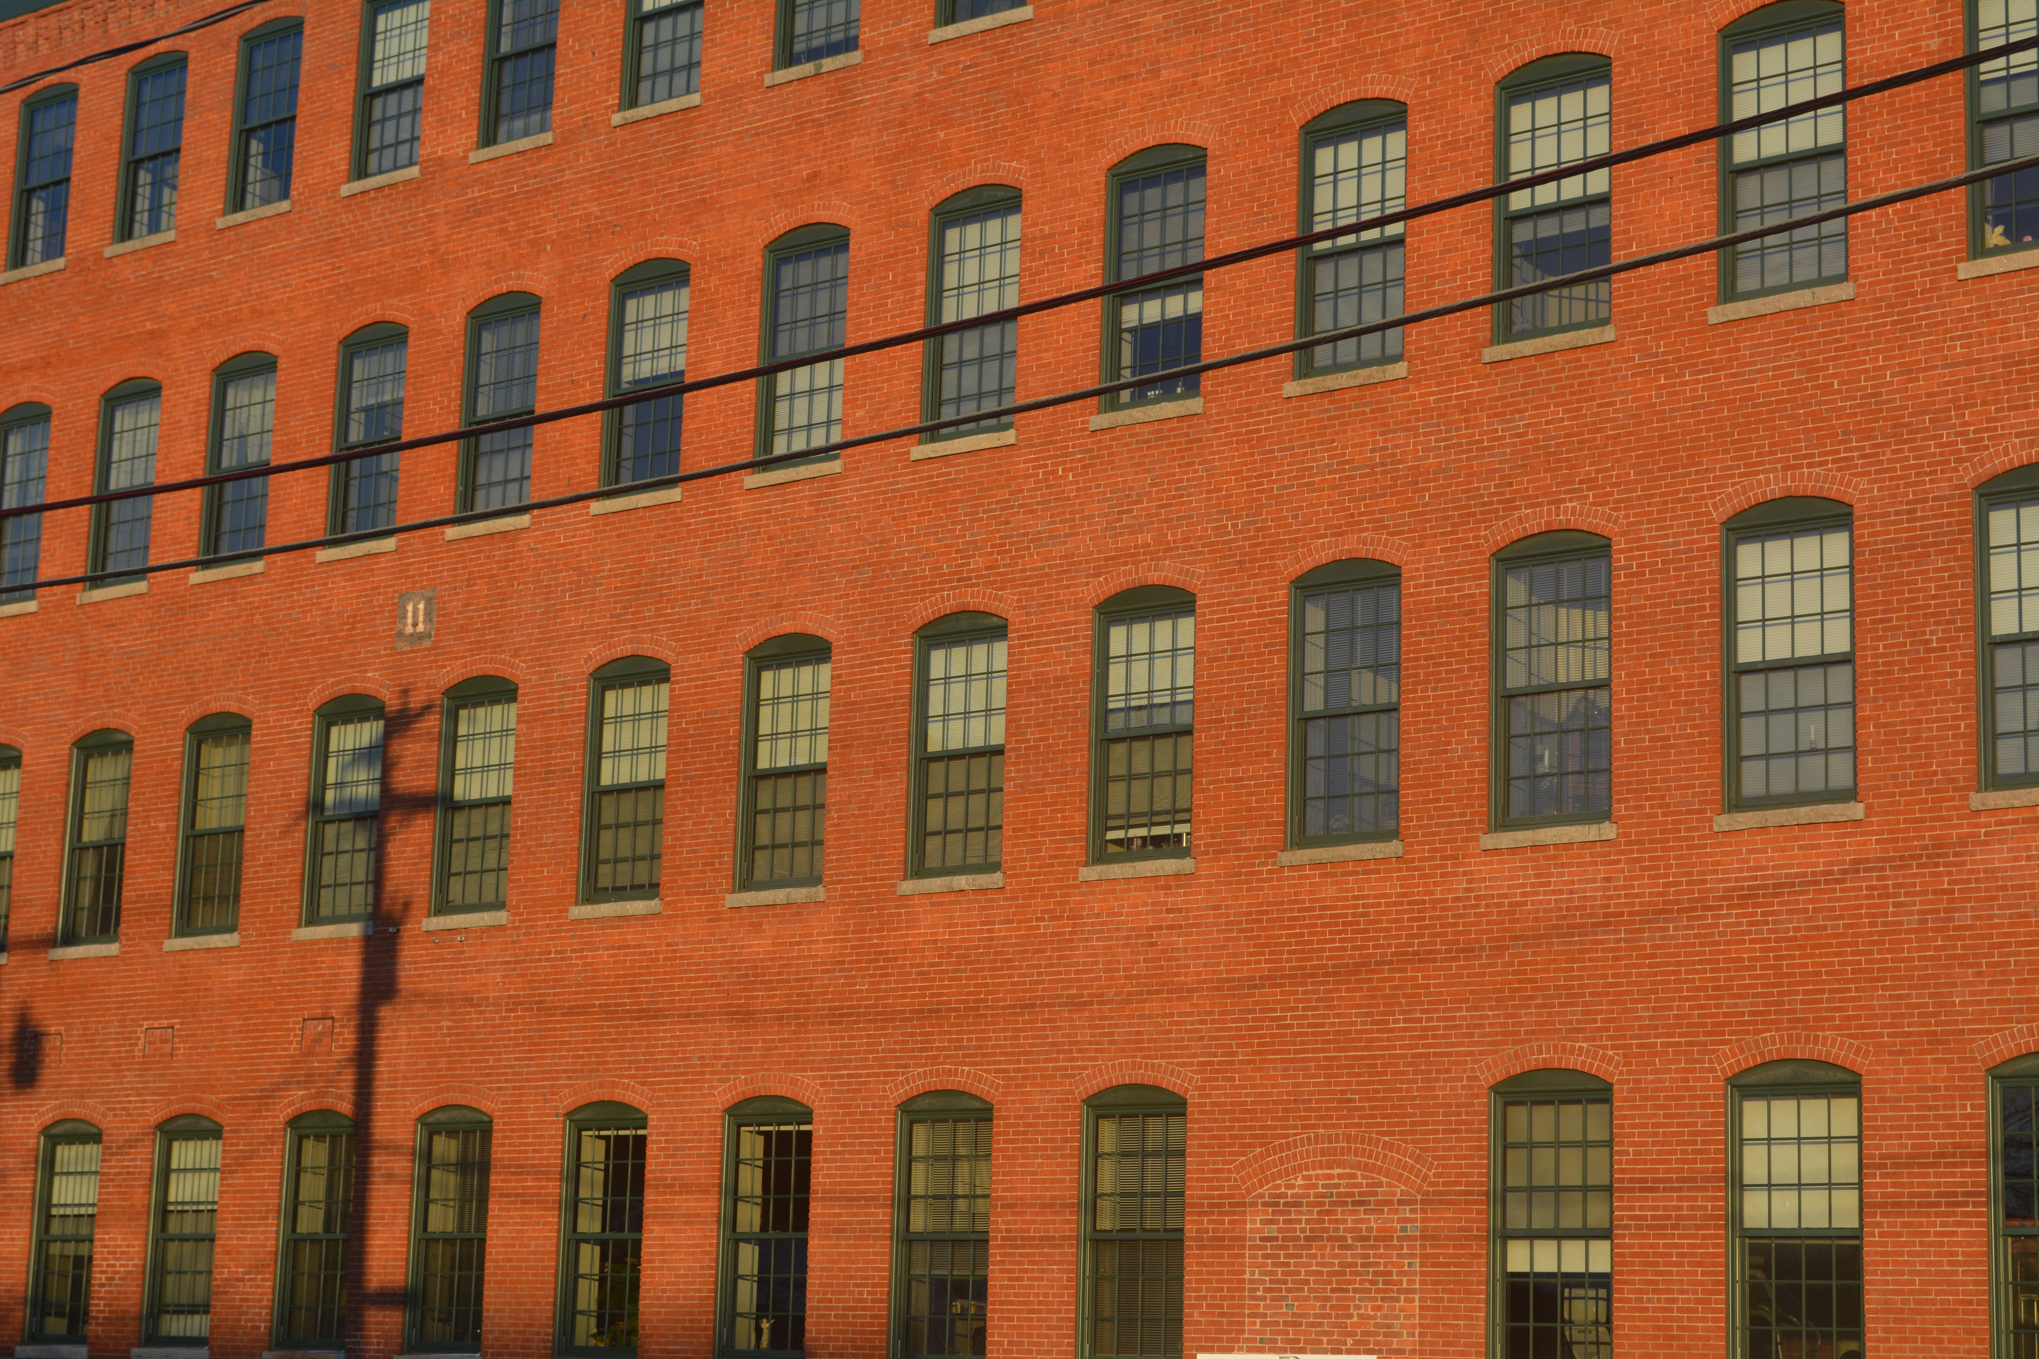
Source: Dodson & Flinker

Environmental Vulnerabilities
Hazardous Materials
Climate change can increase the risk of harm from chemical releases. Floods can result in chemical releases and spills and emergency shutdowns. Extreme heat can increase chemical temperatures increasing risk for explosions. Extreme cold can result in power outages, frozen pipes, and HVAC failure, while storms can result in power outages, HVAC failure, and infrastructure failure. All these climate driven events can increase the risk of chemical release.
- Potential sources of hazardous materials in Gardner are clustered in the center of the City, reflecting its industrial history.
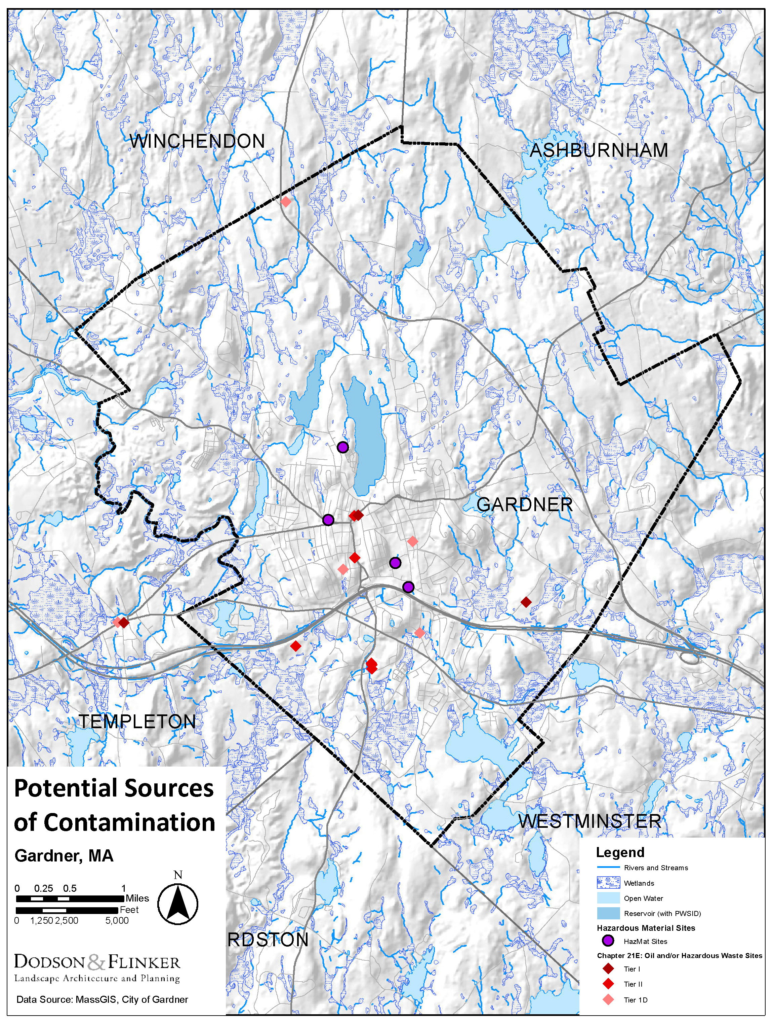
Map of sites with potentially hazardous materials in Gardner

Water Resources, Stormwater, Wastewater
Gardner has extensive wetlands and water resources. Workshop participants primarily viewed these a climate resilience strength for the city. The City’s wetlands and streams are predominantly located on the edges of the City, while the more urban center is home to Crystal Lake, the city’s water supply and underground piped streams. Many of the City’s water resources are surrounded by steep slopes that create well defined flood plains. Extensive wetlands provide natural flood storage. Most of city drains to Otter River and from there to Miller’s River. The northeast corner is part of the Nashua River watershed. Concerns articulated by workshop participants included:
- Crystal Lake, a large drinking water reservoir, is located just uphill from downtown. It lacks a spillway and the City does not have an adequate method for drawing down the river when water levels are high. The City currently uses a pipe to draw down the reservoir when water levels are high, but the pipe’s capacity is insufficient, and it would be extremely difficult to upgrade because the pipe passes under numerous downtown buildings. In recent years, the reservoir has had minimal freeboard during periods with heavy precipitation, despite the City’s drawdown efforts. Workshop participants are very concerned that the reservoir could overtop and flood significant portions of Gardner’s downtown which has both the highest density and lowest income neighborhoods.
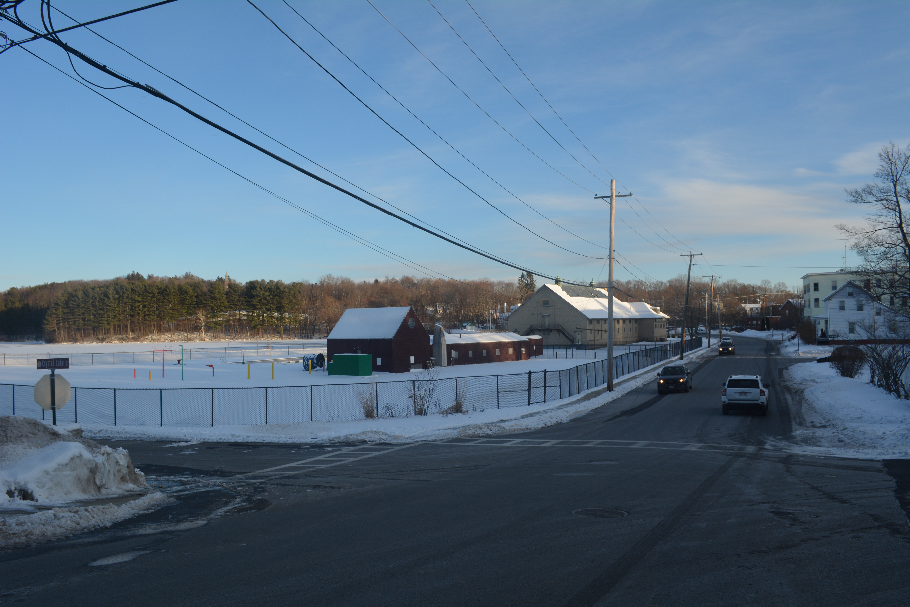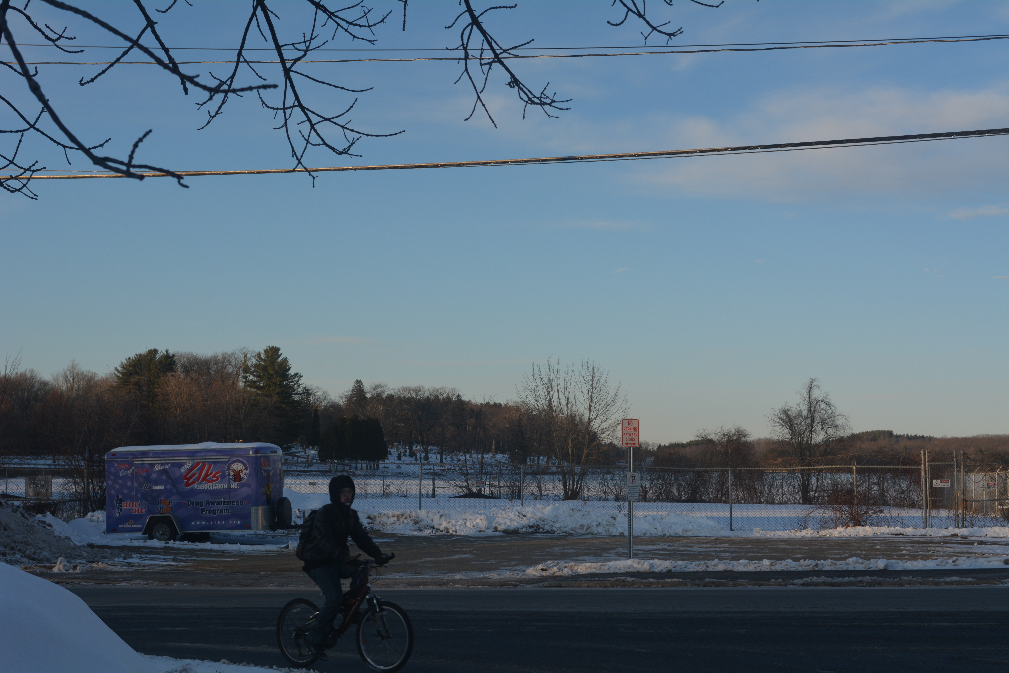
Crystal Lake viewed from Park Street at Graham Street and Park Street at Cottage Street (Source: Dodson & Flinker)
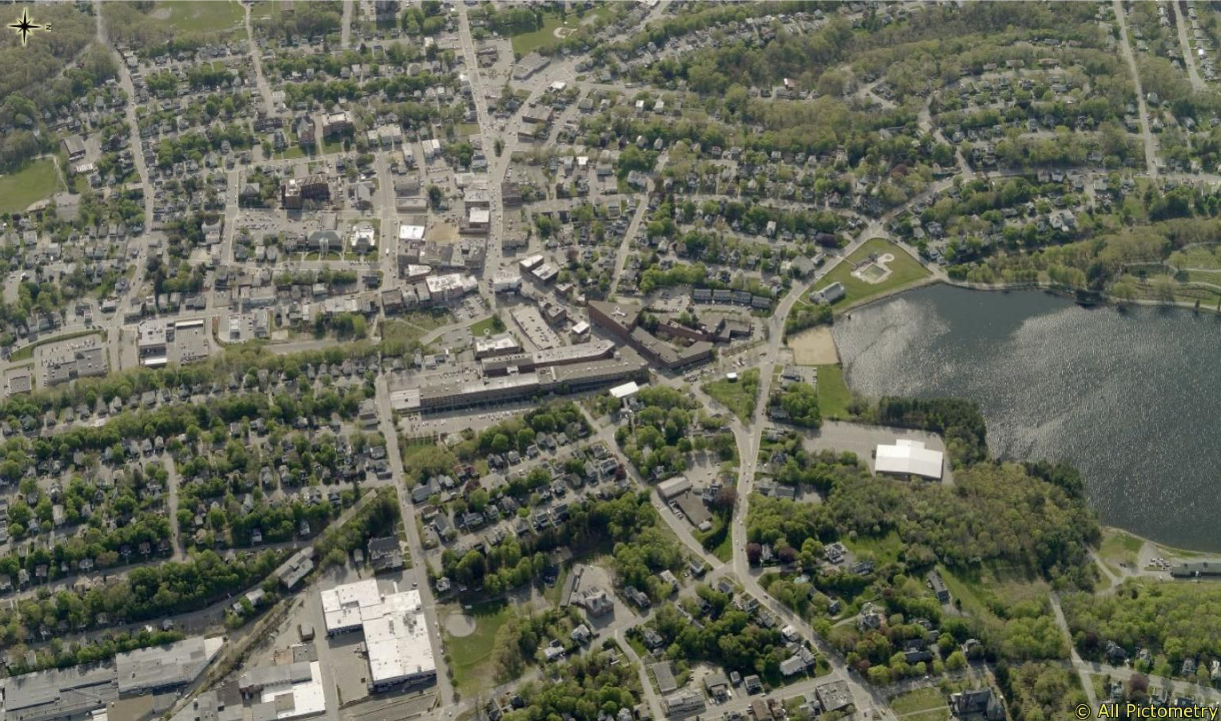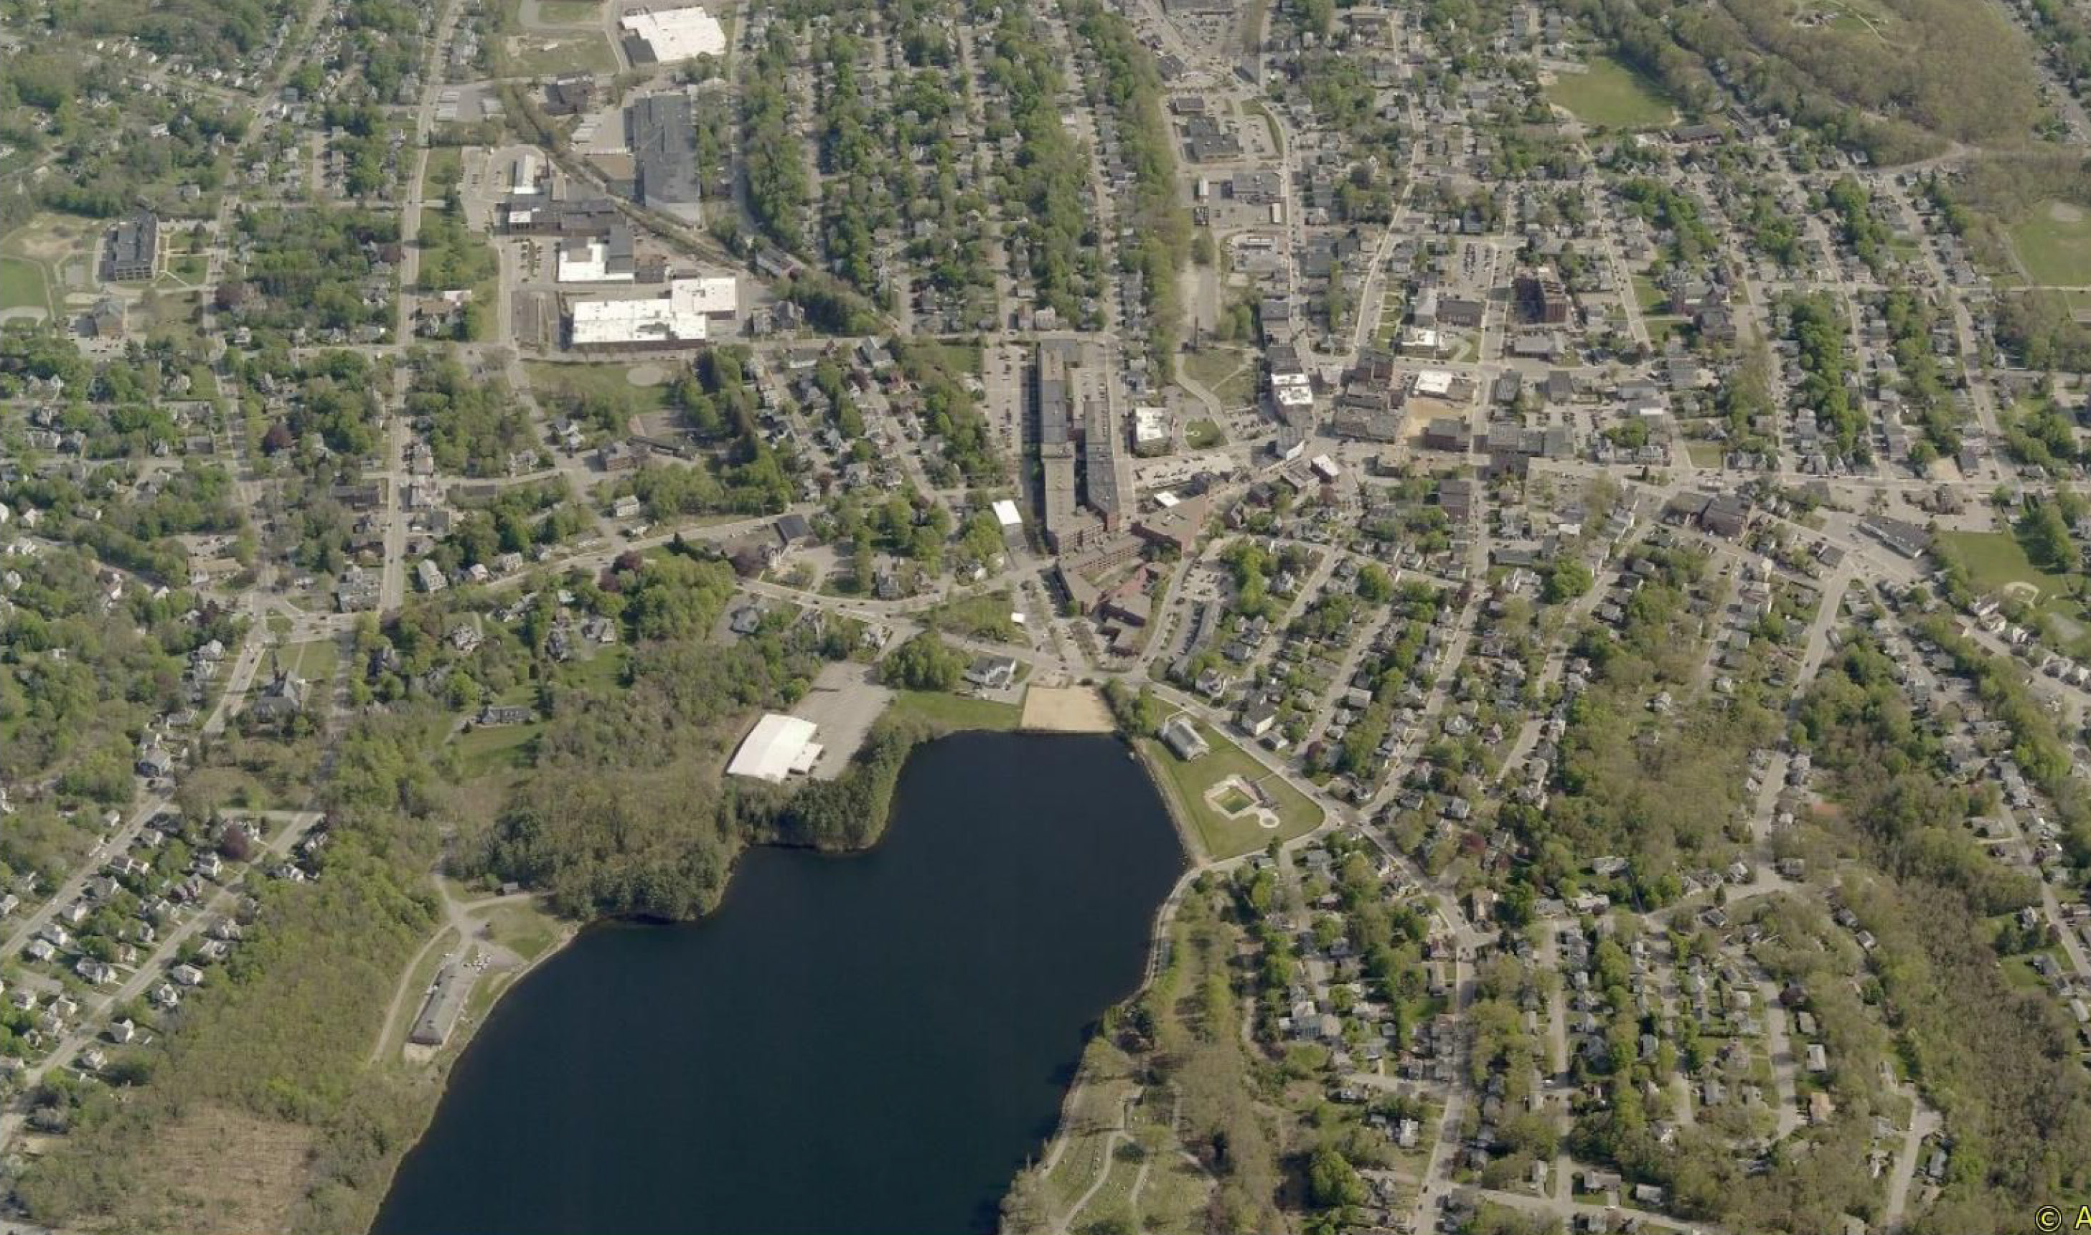
Crystal Lake from the east (top) and north (bottom) showing its proximity to downtown Gardner
(Source: MassDOT Pictometry Viewer)
- Gardner Municipal Golf Course sites immediately north of Crystal Lake. It is a potential source of water contamination, especially nitrogen and pesticides, when the Lake floods.
- Direct untreated runoff from a large shopping plaza enters Foster Brook. Increased storms and precipitation will make this problem worse.
- The town’s stormwater system has been overburdened in the past, resulting in water emerging from storm drains and flooding streets. The City has addressed most of the key problem areas.
- A low-lying swamp adjacent to Route 2A at the end of Gardner Center sometimes floods after heavy rains.
- Sludge Landfill. The City’s Sludge Landfill holds sewage sludge from Gardner’s wastewater treatment facility. Increased intensity of storm events could overburden the stormwater system on site.
- The City of Gardner is in the process of developing a stormwater bylaw or other mechanism for ensuring use of low impact development and/or green infrastructure
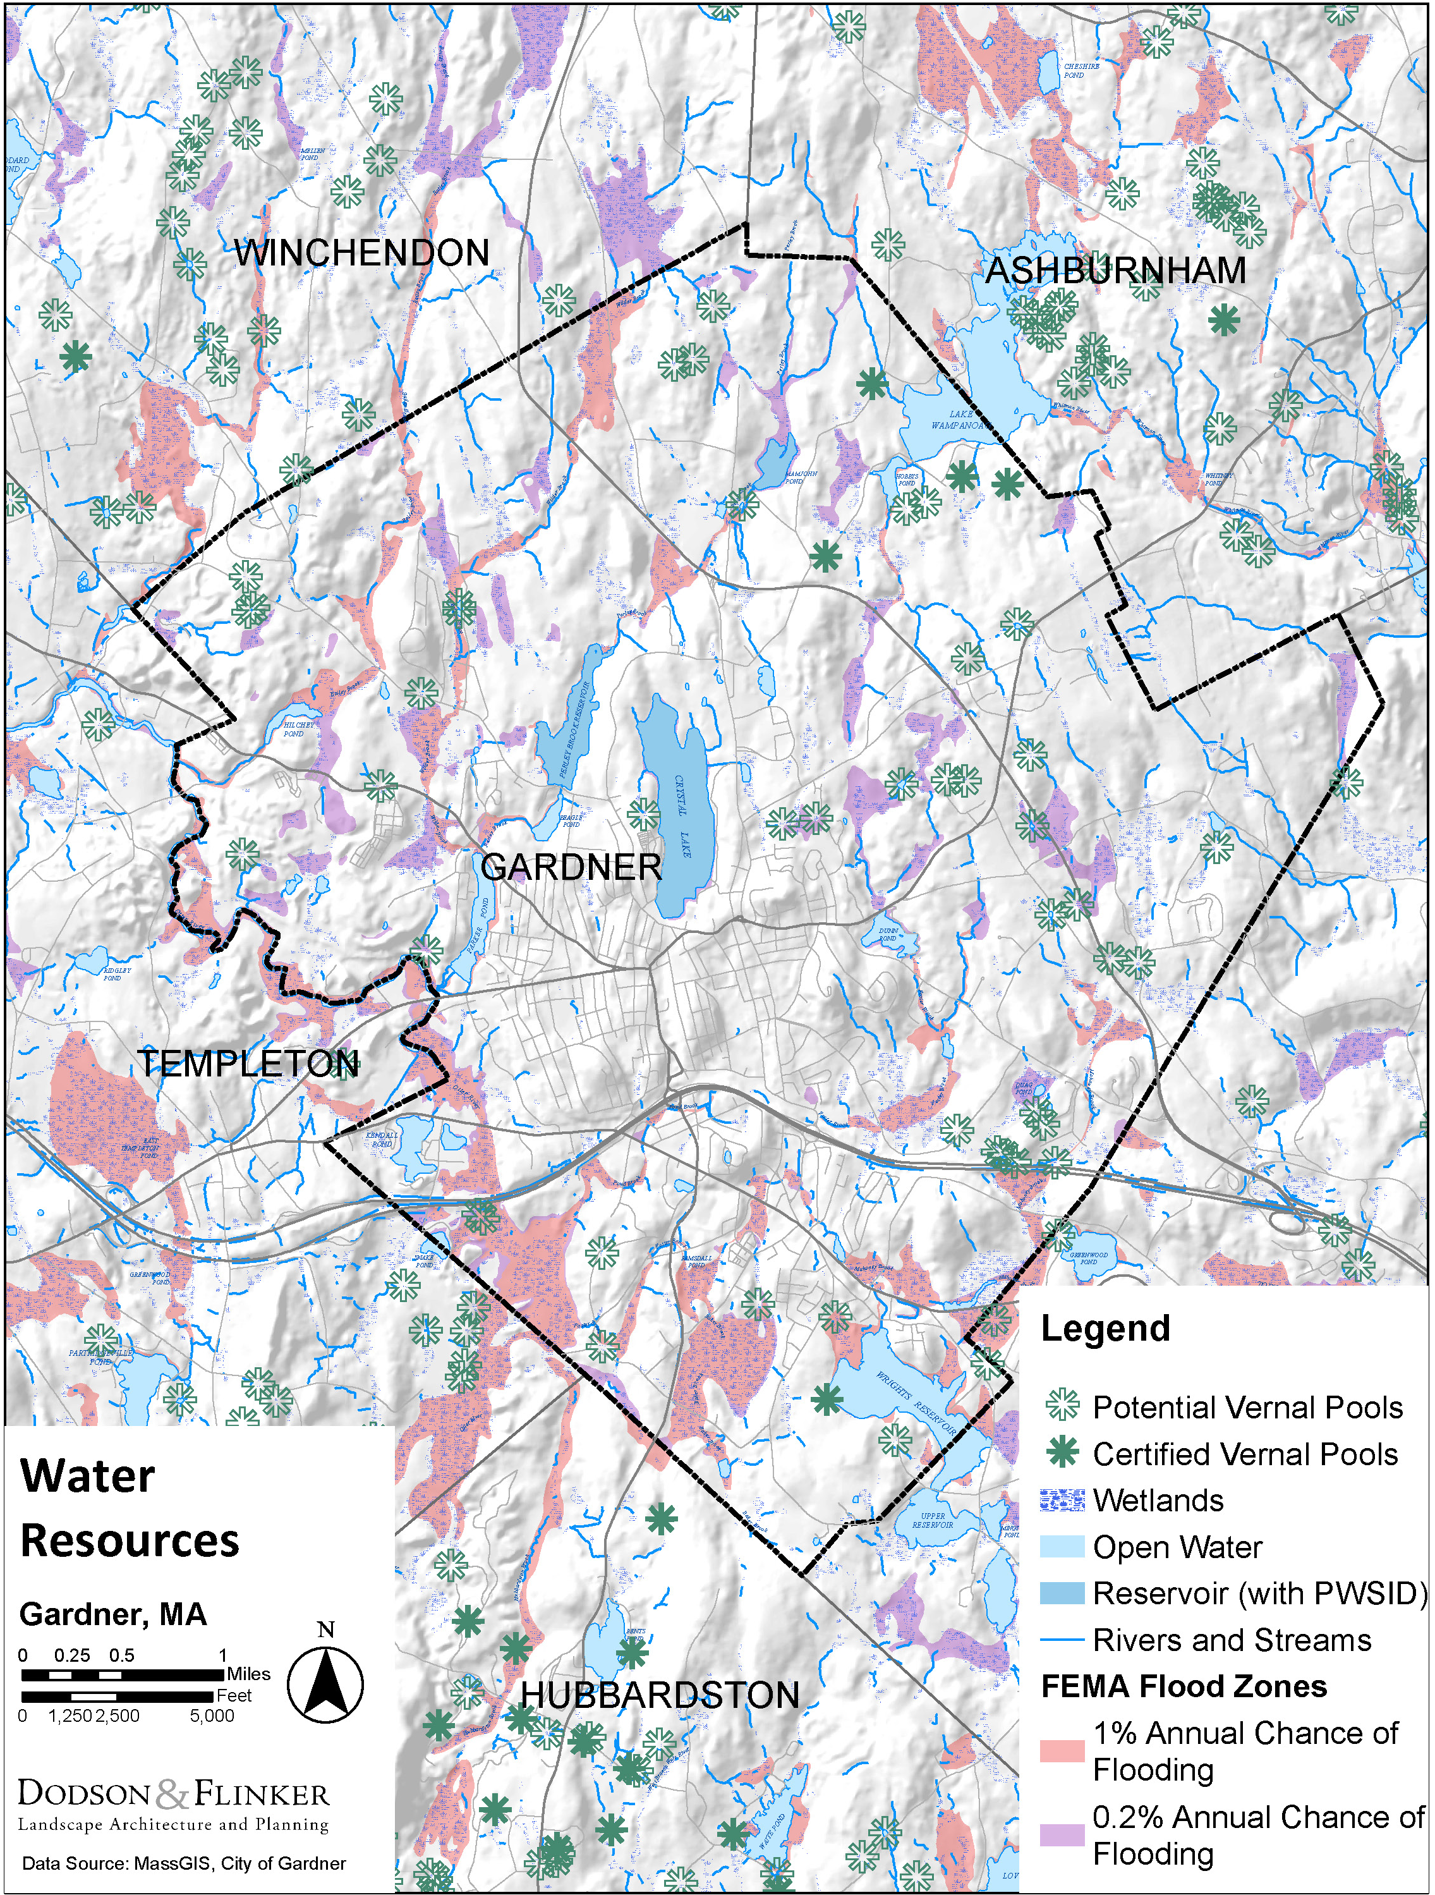
Map of water resources in Gardner

Conservation
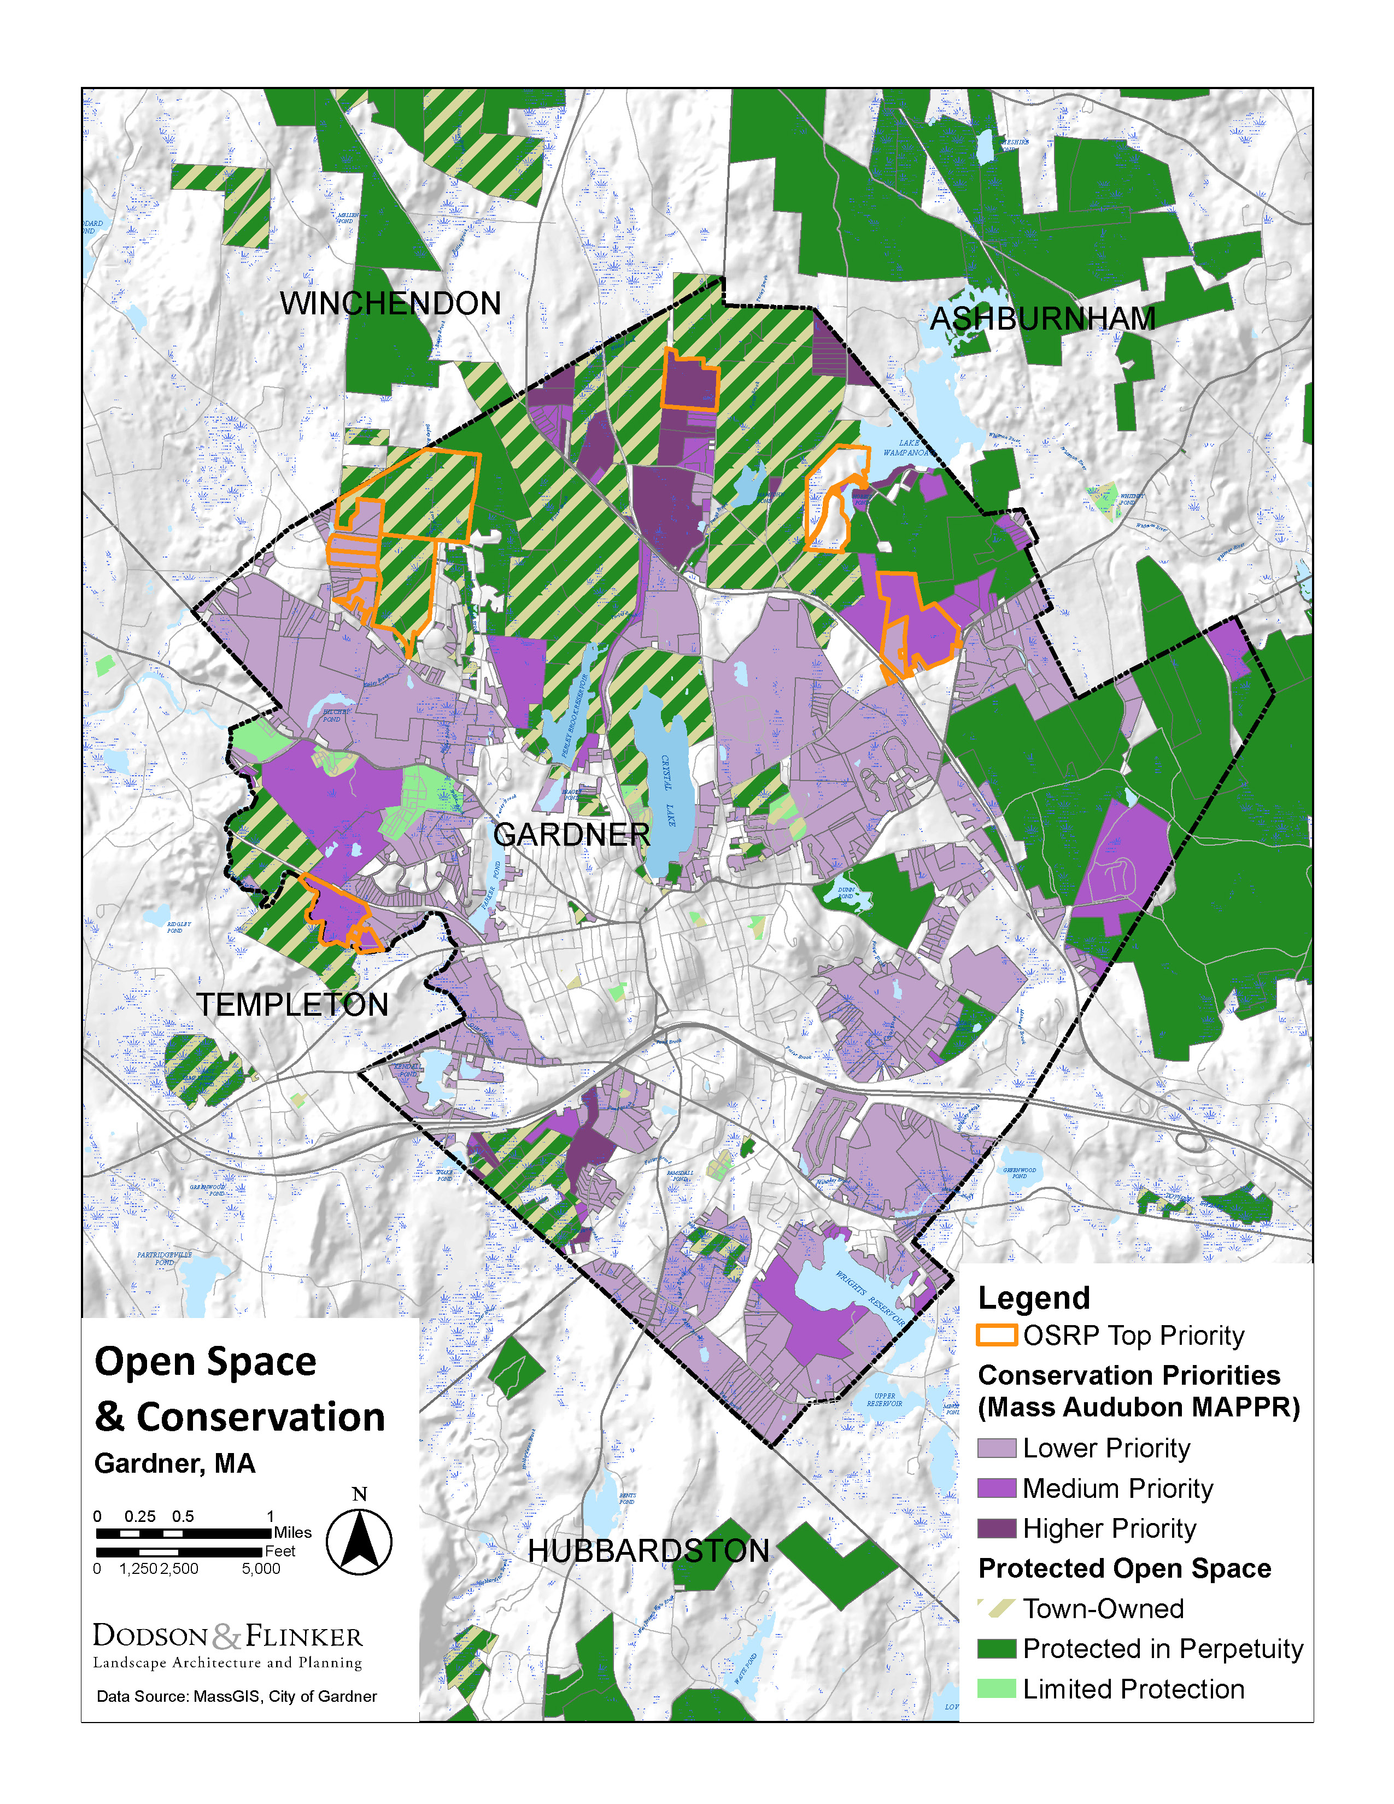
- Approximately 28% of Gardner is conserved (permanently protected from development under current laws). The city added 589 acres of newly conserved land between 2012 and 2019—a 17% increase. Conserved land is concentrated in the northern portion of the City. Properties include Dunn State Park, Gardner Water Supply Land, and Gardner City Forest, Perley Brook Reservoir, Rome Conservation Area, Alisauskas Conservation Area, Bailey Brook Conservation Area, Green Street Conservation Area.
- Although conserved land is one of the city’s greatest climate resilience strengths, there are still high value areas that are not conserved. The City’s Open Space and Recreation Plan (OSRP) identified a number of priority locations for conservation (see map above). These are concentrated in the north part of the city. Mass Audubon’s MAPPR website offers GIS-based analysis of conservation priorities. It largely overlaps with the City’s OSRP priorities, but it shows additional priority locations, including some in the southern portion of the city (see map above). Workshop participants identified the key threats and opportunities below.
- Baker Brook. A large undeveloped area of the floodplain of Baker Brook which drains a large area between Gardner and Hubbardston provides nature-based flood control resiliency and wildlife habitat. Part of this area is protected as open space. However, approximately 20-acres is privately owned.
- Foster Brook. A large undeveloped area of private land of undevelopable wetlands provides substantial nature-based flood control/protection and wildlife habitat. While this area is mostly undevelopable due to wetlands restrictions, it is not permanently protected. The area provides an opportunity for conservation for flood control purposes and the creation of a wildlife corridor with connections to Dunn Pond State Park.
- Cummings Conservation Area. 122 acres that were acquired with Forest Legacy and Water Supply Protection funds. The land includes an undisturbed glacial esker, wetlands, vernal pools, floodplain, and riparian habitat of Otter River. Large, protected forest landscapes, flood zones, and connected riparian corridors increase Gardner’s resilience to climate change. Development pressure outside of the protected areas threaten the resource functions and values within the Conservation Area.
- Quag Pond (Level Kettle Bog). This unique habitat is home to sensitive plants. It is protected, but the sensitivity of this area makes it vulnerable to disruption, especially given the nature of bog habitats.
- Wilder Brook Conservation Area. Protected lands along Wilder Brook provide flood plain protection and wildlife habitat and serves as a critical buffer to adjacent subdivision development. Such areas, when provided for during development planning and approval processes as in this case, protect critical resources and their natural functions and values (such as instream flow quality and quantity, including thermal regimes). Undersized culverts in the vicinity and lack of pretreatment and infiltration of stormwater in this area undermine the resiliency strengths associated with the land protection of this stream ecosystem.

Forests and Urban Forest
- Downtown Gardner has very limited tree cover. This increases local heat island effects, decreases the walkability of the area, increases energy bills for homeowners and businesses, and reduces stormwater uptake by trees. A companion project to this one, also funded by the MVP Program, inventoried trees in downtown Gardner and produced recommendations for improving the urban forest .
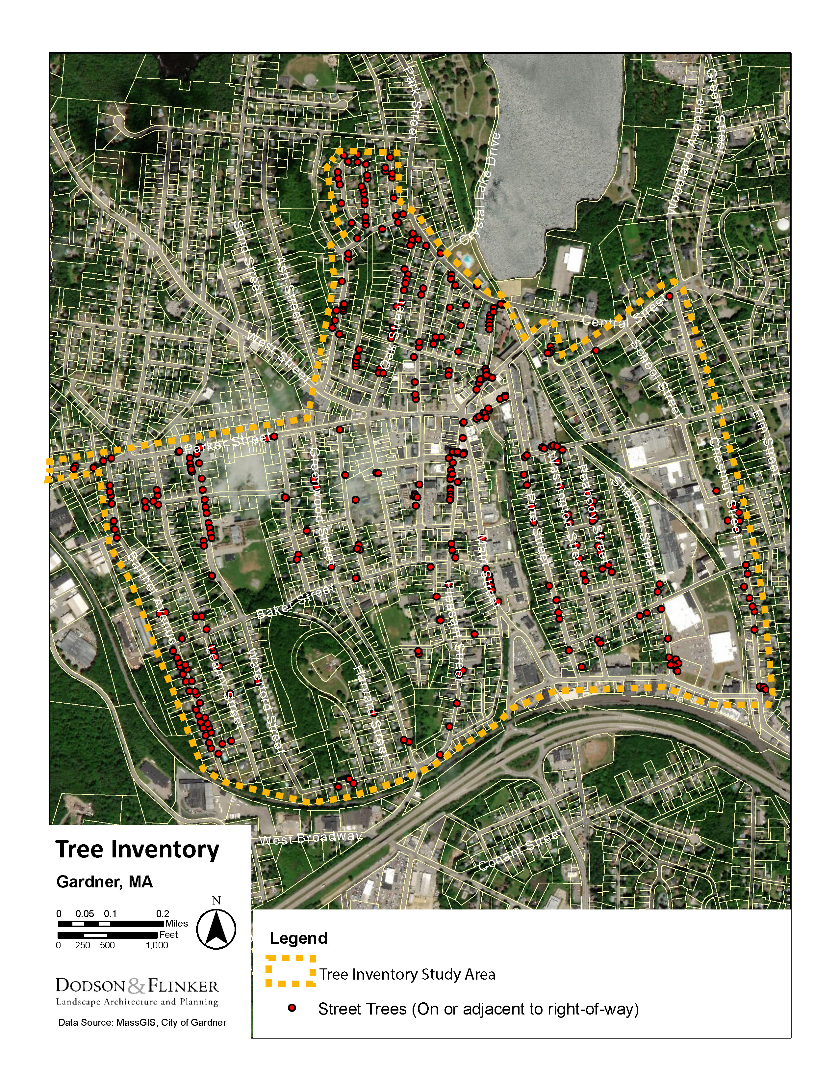
- Many of the key native trees in Gardner’s forests are threatened by invasive insects, pathogens, and/or climate change. Emerald ash borer has been detected in eleven counties in Massachusetts, including Worcester County. It has not been detected in Gardner yet, but the entire state is in a quarantine zone to prevent its spread. Asian Longhorned Beetle is another high concern. It was detected in Worcester in 2008 and eradication efforts are still underway. Hemlock woolly adelgid is another concern.
- Red pine plantations in Gardner present a wildfire risk. Many are dying causing a buildup of woody material on forest floors. Stands near Green Street and Stone Street were cited as a particularly worthy of management.
- Gardner’s forest cart roads provide crucial access for wildfire management. Mapping and maintaining them would ease wildfire response.
- Invasive species are already displacing native species throughout Gardner’s ecosystems. Climate change will make the problem worse.

Environmentally-linked Diseases
- Warmer winter temperatures are likely to increase the number of ticks that carry Lyme disease, babesiosis, and other tick-borne diseases.
- Wetter and warmer conditions lead to increased mosquito populations which can increase human diseases like West Nile Virus, and Eastern Equine Encephalitis (EEE). Warmer winters can result in larger pest populations and increases the spread of tick-borne diseases like Lyme disease and babesiosis.
- Climate change may also increase the spread of water-borne illnesses, especially from contamination during flood events.
- By disrupting ecosystems and animal behaviors across the globe, and changing patterns of human development and food production, climate change may result in increased disease and pandemics in the future.

6. Current Strengths and Assets

Infrastructural Strengths
Transportation
- The City has a robust transportation network with relatively complete network of sidewalks, multi-use paths and trails.
- The City actively engages in transportation improvements including road and sidewalk improvements.
- Gardner’s Municipal Airport could provide access to the City in case of a major disruption to roads.
- Route 2 provides easy access into and out of Gardner. It strengthens the local economy.
- Gardner has a robust sidewalk network. It also has many trails on the outskirts of City, including multi-use paths. The City actively works to improve its bicycle and pedestrian network, for example, by participating in the MassDOT Complete Streets program. The result is a community that is relatively accessible on foot and bicycle. This can reduce the number of motor vehicle trips mitigating climate change. It also provides alternative transportation in case of emergencies—like crippling snowstorms.
- The MART transit system provides dedicated bus routes in Gardner, including a shuttle service between downtown Gardner and Wachusett commuter rail station .
Utilities/Energy Supply
- Gardner has numerous renewable energy installations including at least six large solar installations, and two wind turbine projects. Most of the large-scale solar arrays in the city were installed on former sand, gravel banks, pits, other previously cleared sites. An overlay zone specifies potential renewable energy sites. National Grid’s capacity limits the installation of new renewable energy facilities.
- Many Gardner residents own generators .

Societal Strengths
Community
- Gardner has a strong-knit community. People pitch in when they need to. There is a good network of resources. The experience of the 2008 ice storm taught people how to prepare for and respond to disruptions
- Community Organizations. The City has many active community organizations, including faith-based groups, Gardner VNA, Montachusett Home Care, Montachusett Veterans Association, the Elks, Rotary Club, Polish Club, GAAMHA, Community Action Committee (CAC), and Montachusett Opportunity Council (MOC)
- Gardner has a significant job base and two industrial parks. It has active Economic Development efforts. New employers are coming into the City.
- Mount Wachusett Community College contributes students, jobs, and other resources to the community.
- Heywood Hospital. Hospital services and the medical expertise enriches resident’s overall health and the city’s ability to respond to emergencies.
- Food Security. The school department has a food backpack program and the High School provides fresh food.
- Gardner has active food pantries, including food trucks which are funded by the Hospital.
- Backpack program. Food trucks. Hospital provides funding. High School. Waterford St. Bus stop locations. High School does fresh food.

Town Government/Emergency Management
- Gardner has a well-staffed and committed City government. This will help it prepare for and respond to climate change.
- Reverse 911 Notification System. The city has a highly subscribed reverse 911 notification system with over 15,000 registered phone numbers.
- Gardner uses Code Red actively. It provides both phone and internet notifications.
- Schools have radio communications.
- City Hall has an emergency beacon/button.
- Emergency personnel use broadcast media including the local radio station WGAW at 1340 AM,
- Information can be broadcasted from emergency vehicles and over the public safety agency radio systems.
- The city webpage and the social media networks effectively spread information
- The Police and Fire Departments did wellness checks during ice storms this year, with a focus on older adults.
- The Mayor actively encourages neighbors to check on each other.

Environmental Strengths
- As discussed above, Gardner has over 4,000 acres of permanently conserved land. Much of this protects Gardner’s water resources and provides natural flood attenuation and storage.
- The City has a unique mix of a dense downtown corridor surrounded by lower density and natural areas.

7. Top Recommendations to Improve Resilience to Hazards
Participants in the Community Resilience Building workshop identified dozens of potential actions to improve Gardner’s climate resilience. During the CRB workshop, workshop participants prioritized potential action and whittled them down to a smaller collection of top items. These priorities were subsequently evaluated and prioritized by the Core Team at a meeting after the workshop. They were then reviewed during the Listening Session held on ___________. The top recommendations are described in detail below including recommended next steps, where appropriate. These are followed by lists of other recommended actions, which are organized by the workshop’s three categories of infrastructural, societal, and environmental action items and classified into highest, moderate, and lower priority. The full list of recommended actions is included in the compiled matrix in the Appendix.
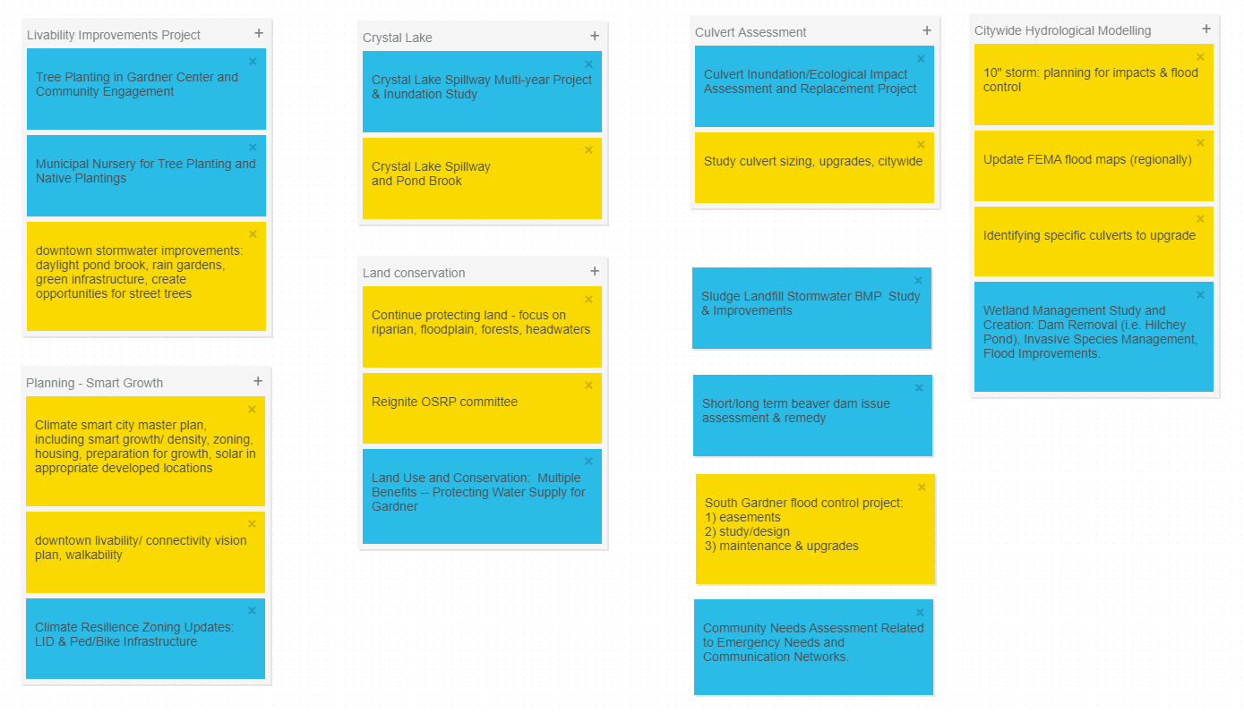
Top Actions as grouped during the CRB Workshop

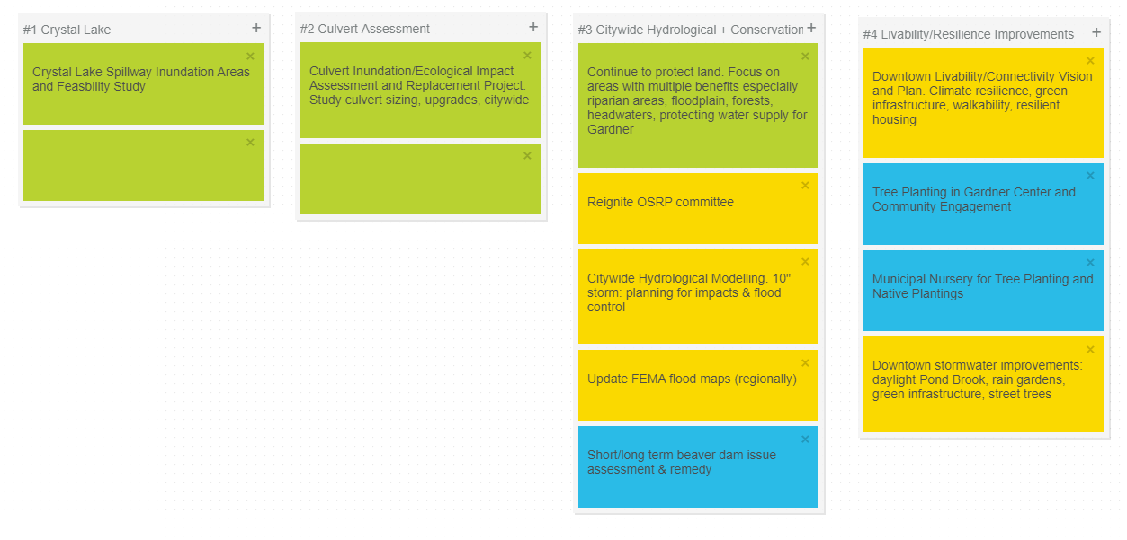
Top Actions as prioritized and grouped by the Core Team after the CRB Workshop
Crystal Lake Spillway
Create a spillway for Crystal Lake so that in the event of future rain storms exacerbated by climate change, the lake does not overtop and flood downtown Gardner which sits immediately downhill of the dike. The spillway would be located on the Northwest side of the lake, through the golf course, under Park Street and into Perley Brook Reservoir. From there, water would follow Perley Brook through Beagle Pond and Parker Pond, and eventually meet the Otter River. Impacts on the Perley Brook and Otter River hydrological systems would have to be assessed.
The project would start with a feasibility study including a hydrology study on the downstream impacts of additional inundation from Crystal Lake on the above-mentioned streams and ponds and surrounding floodplains. The potential for property buyouts for floodplain expansion could be considered if the assessment showed this might be needed.
Design and construction would most likely entail creating a spillway through two of the golf course’s holes where Crystal Lake and Perley Brook Reservoir come closest together. Part of this could be green infrastructure in the form of a vegetated swale, but most likely a portion of it would be an underground piped spillway due to the topography in this narrow stretch of land between the two water bodies. Decades ago, a spillway was proposed for this location, but no progress has been made on this since the late 1970s. Coordination would be necessary between the City, the US Army Corps of Engineers, Dam Safety, and the Golf Superintendent and Commission.

Culvert Assessment
Conduct a city-wide culvert assessment to identify those that need retrofit. The assessment would evaluate the existing structural condition of culverts, and their vulnerability to climate driven hazards including larger stormwater volumes. It would also evaluate the potential ecological restoration if culverts are improved. This would include an assessment of road and stream crossing redundancy, and identifying locations where removal and riparian restoration would benefit Gardner’s ecological infrastructure. The assessment should result in a prioritized list of culvert retrofits and replacements, with estimated design costs and likely funding sources.

Citywide Hydrological and Conservation Assessment
Continue to protect land, with an emphasis on parcels with multiple hydrological benefits. Riparian areas, floodplains, forests, headwaters, and water supply areas would be high priority for protection. Protecting parcels that create connectivity between existing protected areas would be a priority as well, to create robust ecological and hydrological systems throughout Gardner. Wetlands and floodplains can be especially valuable for mitigating the impacts of climate change, because they reduce floods, maintain water quality, and maintain biodiversity among other benefits. Where possible, acquire conservation restrictions or purchase high priority wetlands and floodplains and adjacent properties for floodplain expansion. Partner with land trusts where possible.
This effort should include planning for future rain events that exceed historical averages. Hydrological modeling for a 10” rain event should be included as part of this project, so that flood control and other impacts can be planned for, and land conservation for flood control can be targeted for maximum benefit. Likewise, FEMA flood maps for the region should updated. Long term issues related to flooding from beaver dams should be assessed as well.
The committee from Gardner’s most recent Open Space and Recreation Plan (OSRP) would be helpful in leading this project, and the committee that led that effort could be re-convened.
Livability and Resilience Improvements
Create a downtown livability and connectivity vision plan that creates climate-resilient infrastructure. Green infrastructure improvements like planting shade trees, installing rain gardens, improving sidewalks and trails, developing complete streets, and daylighting streams would build on Gardner’s strength of a walkable downtown while also enhancing climate resilience. The plan would include identifying and prioritizing pedestrian linkages from city neighborhoods to the open space trail networks surrounding downtown. A strategy for creating climate-resilient housing would also be part of the plan.

Additional Priorities
High Priorities
- Community Needs Assessment Related to Emergency Needs and Communication Networks. Conduct an assessment of the City’s emergency response capacity and emergency communication, and identify ways in which these can be improved to meet the demands of future climate-related hazards.
- Climate-Smart Community Development Plan. Update Community Development Plan for Gardner that responds to the ways in which climate change may impact life in the city. Cities like Gardner could see population growth if climate change forces people to relocate from hotter areas or coastal areas. A plan that anticipates growth in Gardner could build on the city’s strengths by encouraging density in its walkable downtown while further protecting its forested open space and water resources. Zoning updates could anticipate the development-related impacts of climate change and direct future growth in ways that intentionally build a more livable, resilient community.
- Dam Removal Wetland Management Study and Implementation. Conduct a study regarding the benefits of dam removal for higher risk dams with greater ecological restoration potential. Hilchey Pond Dam is a higher risk dam that was identified during the MVP process and should be considered for removal and restoration, along with others. Include strategies for invasive species management and flood improvements.
- Sludge Landfill Stormwater BMP Study and Improvements. Conduct a study of stormwater management at the sludge landfill and determine the best management practices that could be implemented to upgrade the existing on-site stormwater system.
- Pursue conservation of high priority parcels, especially those that contribute nature-based flood support, contribute to climate resilience of ecosystems, plants and wildlife, and/or buffer and protect existing conserved areas.

Moderate Priority
- Culverts and stream crossings could be upgraded on an individual basis apart from a citywide plan, including the road to the airport, lower Whitney Street, Chestnut and Main Streets, Keyes Road, Bailey Brook Bridge over Clark Street, Century Way, Parker/Ash/Monadnock, and Bridge Street.
- Improve access to resources for Olde English Village, which houses a lower income population and does not have easy access to the food pantry, emergency shelters, cooling shelters, or other critical resources downtown due to its location. Create pedestrian connections to shopping areas and other nearby resources, as well as improved transit and complete streets to this area.
- Upgrade the stream crossing on the one road leading into Heritage Village. While this would be part of the South Gardner Flood Control project, addressing this one key piece of infrastructure immediately would help prevent the vulnerable population at Heritage Village from losing access to the outside world during a severe rain event.
- Confirm whether CodeRed includes a notification related to power and ensure that people who depend on home medical devices have backup power and communication in the event of a power outage.
- Implement building upgrades or air conditioning upgrades to better cool the middle school and high school, as temperatures increase.
- Designate a larger cooling shelter that can handle larger groups of people for longer periods of time, and make sure its location and availability are well-known.
- Enhance the city’s Reverse-911 system by including the schools’ calling system, which combined would reach a significant portion of the population.
- Create a program of outreach to people who have recently relocated to Gardner, to make sure they are included in emergency-related communication and general hazard preparedness.
- Expand on the local food production system through community gardening, urban agriculture, encouraging local produce, etc. Connect Gardner residents to local / regional food production, through markets, school meals, etc.
- Map and maintain forest cart roads for wildfire protection. Ensure that gates are accessible. Make plans for wildfire response.

Lower Priority
- Support efforts to increase MARTA’s fleet of electric vehicles and provide more bus shelters, especially shelters that include heating and cooling.
- Investigate possibilities for electric vehicle charging stations

8. Possible Funding Sources
Funding for implementation from public sector sources could include:
- MVP Implementation grants from Massachusetts Executive Office of Energy and Environmental Affairs, ranging from $10,000 - $2,000,000 are available to municipalities upon completion of the MVP planning process
- Massachusetts Emergency Management Agency (MEMA) grants
- FEMA’s Hazard Mitigation Grant Program (HMGP)
- MassWorks Infrastructure grants from Massachusetts Executive Office of Housing and Economic Development
- Massachusetts Division of Ecological Restoration’s Culvert Replacement Municipal Assistance grants
- Dam and Seawall Repair or Removal grants from Massachusetts Executive Office of Energy and Environmental Affairs, which addresses inland flood control infrastructure as well as coastal features
- Massachusetts Department of Environmental Protection 604b Water Quality Management Planning Grants
- Other state funds for land conservation
- EPA grants
- See additional grant opportunities on the Massachusetts Community Grant Finder at https://www.mass.gov/lists/community-grant-finder

9. CRB Workshop Invitees and Participants
Community Role | Title/Affiliation | First Name | Last Name | Attended Workshop
Neighborhood Associations | President, Kendall Pond Lake Association | John | Cestone
Forest Landowner-Forested Open Space, Lake Wampanoag | Monadnock Trust | Neil | Erickson
Hydrology | Hydrologist/Gardner Resident | Carl | Carlson | *
Ecosystems/Natural Systems | Forest Ecologist, Harvard Forest | David | Orwig | *
Ecosystems/Natural Systems | Aquatic Biologist/Mass DCR | Jaimie | Carr
Economic development | Economic Development Manager/North Central Mass Development Corporation | Sandie | Cataldo
Arborist | Mass Certified Arborist | Nate | Morrell
Arborist | Mass Certified Arborist | Joseph | Nardelli
Engineering | Former City Engineer | Arthur | Young
Engineering | Former City Engineer | Robert | Hankinson
Land Conservation | Land Protection Specialist | Janet | Morrison
Air Quality | DSG Solutions/Air Quality Engineer | Sean | Gregory, P.E.
Unitil | Forestry Supervisor/Unitil | Dave | Clapham | *
National Grid | Lead Environmental Scientist/National Grid | Dawn | Travalini
Davey Tree - On behalf of National Grid | Certified Arborist/Davey Tree Expert Company | Jeff | Meola
Ameresco Solar | Commercial Solar Energy | Nabih | Younis
Heartwood Solutions | Commercial Solar Energy | Fred | Unger
Mass Audubon | Climate Change Adaptation Ecologist | Danielle | Perry | *
Mass Audubon | Regional Scientist | Tom | Lautzenheiser | *
Mt Grace Land Trust | Conservation Director | Sarah | Wells
Mt Grace Land Trust | Community Conservation Program Manager | Fletcher | Harrington | *
North County Land Trust | Executive Director | Anna | Wilkins | *
North County Land Trust | Director of Land Conservation | Jassy | Bratko
Greater Gardner CDC /NewVue Communities | Executive Director | Marc | Dohan
Mt Wachusett College | President | James | Vander Hooven
Heywood Hospital | Director of Resource Development | Mary | Giannetti
Community Health Network of North Central Mass (CHNA9) | Executive Director | Chelsey | Patriss
MVP Regional Coordinator | MVP Regional Coordinator - GCRV | Andrew | Smith | *
Regional Planning Agency | Regional Planner | John | Hume
Mass Division of Conservation & Recreation (DCR) | Park Supervisor | Tim | Culkeen
Mass Fish & Wildlife - High Ridge Wildlife Management Area |  | Todd | Olanyk
State Senator |  | Dean | Tran
State Reps |  | John | Zlotnik
City Boards
Gardner Redevelopment Authority | Director of Community Dev. & Planning | Trevor | Beauregard | *
Gardner Redevelopment Authority | Chairman-GRA | Ronald F. | Cormier
Gardner Redevelopment Authority | Treasurer-GRA | Neil W. | Janssens
Gardner Redevelopment Authority | Clerk-GRA | Timothy J. | Horrigan
Gardner Redevelopment Authority | State Appointed Member-GRA | Paul G. | Tassone
Gardner Redevelopment Authority | Assistant Treasurer-GRA | M. Paul | Carlberg
Planning Board | Chairman-Planning Board | Mark | Schafron
Planning Board | Vice Chairman-Planning Board | Robert J. | Swartz | *
Planning Board | Member-Planning Board | Robert J. | Bettez
Planning Board | Member-Planning Board | Paul A. | Cormier
Planning Board | Member-Planning Board | Stephen E. | Cormier
ZBA | Chairman-ZBA | Ray | Lafond
ZBA | Clerk-ZBA | Michael D. | Gerry
ZBA | Third Member-ZBA | Randall W. | Heglin
ZBA | Alternate Member (1st)-ZBA | David | Antaya
ZBA | Alternate Member (2nd)-ZBA | Melory | Cornett
Conservation Commission | Chairman-Conservation | Greg | Dumas
Conservation Commission | Member-Conservation | David | Beauregard
Conservation Commission | Member-Conservation | Norman H. | Beauregard, Jr.
Conservation Commission | Member-Conservation | Donna | Lehtinen
Conservation Commission | Member-Conservation | Michael | Hermanson | *
Conservation Commission | Member-Conservation | Duncan | Burns, Jr.
Conservation Commission | Member-Conservation | David | Orwig | *
Conservation Commission | Alternate Member/Stewardship Volunteer | Martin | Bowers
Disability Commission | ADA Coordinator | Deb | Pond
Historical Commission | Chairman | Chuck | LaHaye
School Committee/PTO | Chairman/Acting Mayor | James | Walsh
School Committee/PTO | Vice Chair | Jennifer | Zlotnik-Pelavin
School Committee/PTO | Member | James | Abare
School Committee/PTO | Member | Rachel | Cormier
School Committee/PTO | Member | Anne | Hurst
School Committee/PTO | Member | John | LaFreniere
School Committee/PTO | Member | Robert J. | Swartz | *
School Committee/PTO | Recording Secretary | Terri | Hillman
City Staff
Mayor | Acting Mayor | James | Walsh
City Council President | City Council - President | James | Walsh
City Council Member | City Council - Councilor at-Large | James | Boone
City Council Member | City Council - Councilor at-Large | Craig | Cormier
City Council Member | City Council - Councilor at-Large | Ronald | Cormier
City Council Member | City Council - Councilor at-Large | Scott Joseph | Graves
City Council Member | City Council - Councilor at-Large | Judy | Mack
City Council Member | City Council - Councilor at-Large | George | Tyros
City Council Member | City Council - Ward 1 Councilor | James | Walsh
City Council Member | City Council - Ward 2 Councilor | Elizabeth | Kazinskas
City Council Member | City Council - Ward 3 Councilor | Nathan | Boudreau
City Council Member | City Council - Ward 4 Councilor | Karen | Hardern
 | City Council-Ward 5 Councilor | Alek | Dernalowicz
Planning Department | Director of Community Dev. & Planning | Trevor | Beauregard | *
Planning Department | Assistant Director | Jeff | Legros | *
Economic Development | Economic Development Coordinator | Maribel | Cruz
Conservation | Conservation Agent | Lyndsy | Butler | *
DPW | Director | Dane | Arnold
DPW | Assistant Director | Robert | Oliva | *
Engineering | City Engineer | Chris | Coughlin | *
Engineering | GIS Coordinator | Rachel | Catlow | *
Police Department | Police Chief | Richard | Braks
Police Department | Deputy Police Chief | Jim | Trifiro
Fire Department | Fire Chief | Richard | Ares
Fire Department | Captain | Greg | Lagoy
Emergency Management | Director of Civil Defense | Paul | Topolski
Other EMS - Woods Ambulance | General Manager | Jennifer | Wood
Board of Health/Health Department | Director | Lauren | Saunders
Board of Health/Health Department | Assistant Director | Rick | Rossi
Senior Center | Senior Citizens Director | Claude | Leger
Parks and Recreation | Public Pool and Slash Park Mngr. | Diana | Ringer
Housing Authority | Executive Director | Sandra | Mullins

10. Acknowledgements
Gardner to supply

11. MVP Project Team
First Name | Last Name | Title/Role | Affiliation
Trevor | Beauregard | Director, Dept. of Community Development & Planning | City of Gardner
Jeff | Legros | Assistant Director, Community Development & Planning | City of Gardner
Dane | Arnold | Director, Dept. of Public Works | City of Gardner
Rob | Oliva | Assistant Director, Dept. of Public Works | City of Gardner
Chris | Coughlin | City Engineer | City of Gardner
Rachael | Catlow | GIS Coordinator/Energy Manager | City of Gardner
Paul | Topolski | Civil Defense Director | City of Gardner
Richard | Braks | Police Chief | City of Gardner Police Department
Anna | Wilkins | Executive Director | North County Land Trust
Fletcher | Harrington | Community Conservation Program Manager | Mount Grace Land Trust
Ivan | Ussach | Watershed Coordinator | Millers River Watershed Council
John | Hume | Regional Planner; Gardner Resident | Montachusett Regional Planning Commission
Julie | Meehan | Executive Director | Gardner Community Action Committee
David | Orwig | Forest Ecologist; Conservation Commission Member | Harvard Forest; Gardner Con Com
David | Beauregard | Conservation Commission Member | Gardner Con Com
Bob | Swartz | Planning Board Member | Gardner Planning Board
Andrew | Smith | MVP Program Greater Connecticut River Valley Area Coordinator | MVP Program
Peter | Flinker | Principal-in-Charge, Workshop Facilitator | Dodson & Flinker
Nate | Burgess | Facilitator | Dodson & Flinker
Dan | Shaw | Project Lead, Facilitator | Dodson & Flinker
Dillon | Sussman | Project Lead, Facilitator | Dodson & Flinker

12. Citation
City of Gardner (2020). Community Resilience Building Workshop Summary of Findings. City of Gardner, Dodson & Flinker. Gardner, MA

13. References
American Public Health Association. “How Climate Change Affects Your Health.” APHA. Accessed September 16, 2020. https://www.apha.org/news-and-media/multimedia/infographics/how-climate-change-affects-your-health.
Mass.gov. “Baker‐Polito Administration Helps Cities and Towns Upgrade Road-Stream Crossings.” Accessed April 12, 2020. https://www.mass.gov/news/baker-polito-administration-helps-cities-and-towns-upgrade-road-stream-crossings-0.
Benevolenza, Mia A., and LeaAnne DeRigne. “The Impact of Climate Change and Natural Disasters on Vulnerable Populations: A Systematic Review of Literature.” Journal of Human Behavior in the Social Environment 29, no. 2 (February 17, 2019): 266–81. https://doi.org/10.1080/10911359.2018.1527739.
“Dam Removal and Ecological Benefit Estimation Tool.” Accessed April 18, 2020. https://mass-eoeea.maps.arcgis.com/apps/MapTools/index.html?appid=f573dc437265480f87e31f413e527a3c.
Derrig, Dave, Dave Patnaude, Nancy Farrell, Francis Mahady, and Joanne Haracz. “I-90 Interchange Study.” MassDOT, February 2020. https://www.mass.gov/doc/i-90-interchange-study-final-report/download.
ResilientMA Climate Change Clearinghouse fort the Commonwealth: Transportation. “MA Climate Change Clearinghouse.” Accessed April 12, 2020. https://www.resilientma.org/sectors/transportation.
Madsen, Travis, and Nathan Wilcox. “When It Rains, It Pours: Global Warming and the Increase in Extreme Precipitation from 1948 to 2011.” Environment America Research and Policy Center, Summer 2012. https://environmentamericacenter.org/reports/ame/when-it-rains-it-pours.
MAPC. “Housing Gardner MA.” Accessed September 28, 2020. http://www.housing.ma/gardner/report.
Mass Audubon. “Losing Ground 2020: Statistics, Gardner.” Losing Ground 2020: Statistics, Gardner. Accessed September 30, 2020. https://www.massaudubon.org/our-conservation-work/advocacy/shaping-the-future-of-your-community/publications-community-resources/losing-ground/statistics/town/gardner.
Massachusetts Department of Public Health, Bureau of Environmental Health. “Climate and Health Pathways | MEPHT.” Accessed September 16, 2020. https://matracking.ehs.state.ma.us/Climate-Change/conceptual-pathways.html#MyPopup.
———. “Heat Vulnerablity Index Map for Massachusetts | MEPHT.” Accessed September 16, 2020. https://matracking.ehs.state.ma.us/Climate-Change/map-hvi.html.
“Massachusetts State Hazard Mitigation and Climate Adaptation Plan.” Massachusetts Emergency Management Agency (MEMA) and Massachusetts Executive Office of Energy and Environmental Affarids (EOEEA), 2018. https://www.mass.gov/files/documents/2018/10/26/SHMCAP-September2018-Full-Plan-web.pdf.
Meyer, Michael D., and Brent Weigel. “Climate Change and Transportation Engineering: Preparing for a Sustainable Future.” Journal of Transportation Engineering 137, no. 6 (June 2011): 393–403. https://doi.org/10.1061/(ASCE)TE.1943-5436.0000108.
Montachusett Regional Planning Commission. “Montachusett Region Natural Hazard Mitigation Plan 2015 Update.” Montachusett Regional Planning Commission, 2015. https://www.mrpc.org/sites/g/files/vyhlif3491/f/uploads/montachusett_region_natural_hazard_mitigation_plan_2015_update_adopted_by_communities.pdf.
Motanya, Njideka C., and Pamela Valera. “Climate Change and Its Impact on the Incarcerated Population: A Descriptive Review.” Social Work in Public Health 31, no. 5 (July 28, 2016): 348–57. https://doi.org/10.1080/19371918.2015.1137513.
Nasr, Amro, Erik Kjellström, Ivar Björnsson, Daniel Honfi, Oskar L. Ivanov, and Jonas Johansson. “Bridges in a Changing Climate: A Study of the Potential Impacts of Climate Change on Bridges and Their Possible Adaptations.” Structure and Infrastructure Engineering 16, no. 4 (April 2, 2020): 738–49. https://doi.org/10.1080/15732479.2019.1670215.
National Climate Assessment. “National Climate Assessment.” Accessed September 15, 2020. https://nca2014.globalchange.gov/node/5663.
“National Inventory of Dams.” Accessed April 21, 2020. https://nid.sec.usace.army.mil/ords/f?p=105:22:6515669010501::NO:::
Northeast Climate Adaptation Science Center. “Massachusetts Climate Change Projections.” Resilient MA Climate Change Clearinghouse for the Commonwealth (resilient MA), 2018.
Mass.gov. “Office of Dam Safety.” Accessed April 18, 2020. https://www.mass.gov/office-of-dam-safety.
Sims, Katharine R. E., Jonathan R. Thompson, Spencer R. Meyer, Christoph Nolte, and Joshua S. Plisinski. “Assessing the Local Economic Impacts of Land Protection.” Conservation Biology 33, no. 5 (2019): 1035–44. https://doi.org/10.1111/cobi.13318.
Strate, Susan. “RE: 2018 Vintage Population Projections Full Report,” April 24, 2020.
“TechBrief: Climate Change Adaptation for Pavements, FHWA-HIF-15-015.” U.S. Department of Transportation, Federal Highway Administration, August 2015. https://www.fhwa.dot.gov/pavement/sustainability/hif15015.pdf.
Tiffany Skogstrom. “OTA Resources & Climate Change Preparedness.” 2017. https://www.mass.gov/files/documents/2017/11/20/Skogstrom%20chem%20safety.pdf.
UMass Donahue Institute. “Massachusetts Population Projections.” UMass Donahue Institute: Population Estimates Program, 2020. https://public.tableau.com/views/UMDIProjections/MassachusettsPopulationProjections?:embed=y&:display_count=y?:embed=y&:showVizHome=no&:host_url=https%3A%2F%2Fpublic.tableau.com%2F&:embed_code_version=3&:toolbar=yes&:animate_transition=yes&:display_static_image=no&:display_spinner=no&:display_overlay=yes&:display_count=yes&:loadOrderID=0.
United States Census Bureau. “Poverty Status in the Past 12 Months.” Accessed September 28, 2020. https://data.census.gov/cedsci/table?q=poverty%20children%20gardner%20ma&tid=ACSST5Y2018.S1701&hidePreview=false.

14. Appendices
- Combined Workshop Matrix

Northeast Climate Adaptation Science Center, “Massachusetts Climate Change Projections.”
Madsen and Wilcox, “When It Rains, It Pours: Global Warming and the Increase in Extreme Precipitation from 1948 to 2011.”
Northeast Climate Adaptation Science Center, “Massachusetts Climate Change Projections.”
Montachusett Regional Planning Commission, “Montachusett Region Natural Hazard Mitigation Plan 2015 Update.”
American Public Health Association, “How Climate Change Affects Your Health.”
Massachusetts Department of Public Health, Bureau of Environmental Health, “Climate and Health Pathways | MEPHT.”
“National Climate Assessment.”
American Public Health Association, “How Climate Change Affects Your Health.”
Massachusetts Department of Public Health, Bureau of Environmental Health, “Climate and Health Pathways | MEPHT.”
Massachusetts Department of Public Health, Bureau of Environmental Health.
“National Climate Assessment.”
Northeast Climate Adaptation Science Center, “Massachusetts Climate Change Projections.”
American Public Health Association, “How Climate Change Affects Your Health.”
“TechBrief: Climate Change Adaptation for Pavements, FHWA-HIF-15-015.”
“MA Climate Change Clearinghouse.”
Meyer and Weigel, “Climate Change and Transportation Engineering.”
Nasr et al., “Bridges in a Changing Climate.”
“Baker‐Polito Administration Helps Cities and Towns Upgrade Road-Stream Crossings.”
Nasr et al., “Bridges in a Changing Climate.”
Meyer and Weigel, “Climate Change and Transportation Engineering.”
“Office of Dam Safety.”
“National Inventory of Dams.”
“Dam Removal and Ecological Benefit Estimation Tool.”
“Massachusetts State Hazard Mitigation and Climate Adaptation Plan.”
Benevolenza and DeRigne, “The Impact of Climate Change and Natural Disasters on Vulnerable Populations.”
“Massachusetts State Hazard Mitigation and Climate Adaptation Plan.”
An environmental justice area based on income is an area that has a median income less than or equal to 65% of the state median income. The designation was last completed based on 2010 Census Data. Based on 2018 ACS 5-year data, the area would no longer meet the criteria, but the 2010 designation is still in place.
Motanya and Valera, “Climate Change and Its Impact on the Incarcerated Population.”
“Housing Gardner MA.”
“Poverty Status in the Past 12 Months.”
Massachusetts Department of Public Health, Bureau of Environmental Health, “Heat Vulnerablity Index Map for Massachusetts | MEPHT.”
UMass Donahue Institute, “Massachusetts Population Projections.”
Strate, “RE: 2018 Vintage Population Projections Full Report,” April 24, 2020.
Tiffany Skogstrom, “OTA Resources & Climate Change Preparedness.”
Mass Audubon, “Losing Ground 2020: Statistics, Gardner.”

